***Github Repo Url :***

[**https://github.com/karthikeyanrajan/karthikeyanrajan-capstone-project.git**](https://github.com/karthikeyanrajan/karthikeyanrajan-capstone-project.git)

**This Repo Contains three branches :**

**Main branch**

* On main branch the all Project files are available
* On project-submission-files folder - Configurationfiles folder - installation steps & config files are uploaded
* On project-submission-files folder - Screenshots are uploaded

**Dev branch**

* On dev branch uploaded with jenkins pipeline files

**Master branch**

* On master branch uploaded with jenkins pipeline files

***Note:  
To see particular pictures mentioned in this document***

**In this Picture Name is marked with numbers refer the → main branch project-submission-files folder - Screenshots are uploaded with numbers**

***Project:***

**Docker Image name :**By using the build.sh the builded docker image name is :

**REPOSITORY TAG**    
 reactjs-demo latest

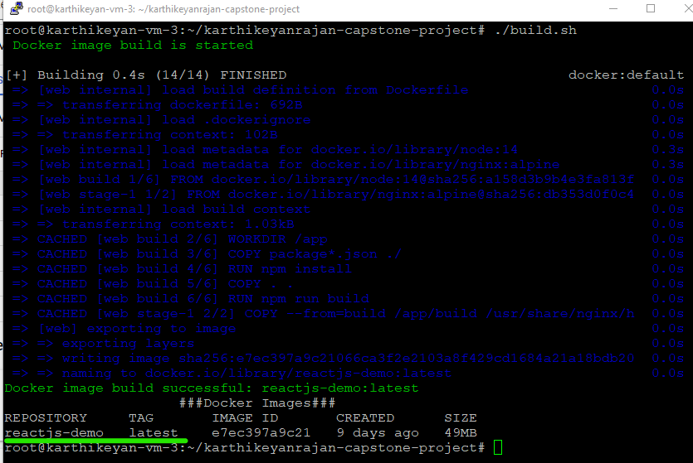

Picturename : 01.bash script build.sh

By using the deploy.sh the deployed docker container name is : **reactjscontainer**

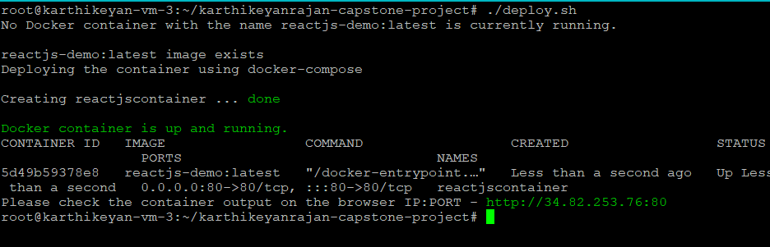

Picturename: 02.bash script deploy.sh

Deployed site URL - **http://34.82.253.76:80**

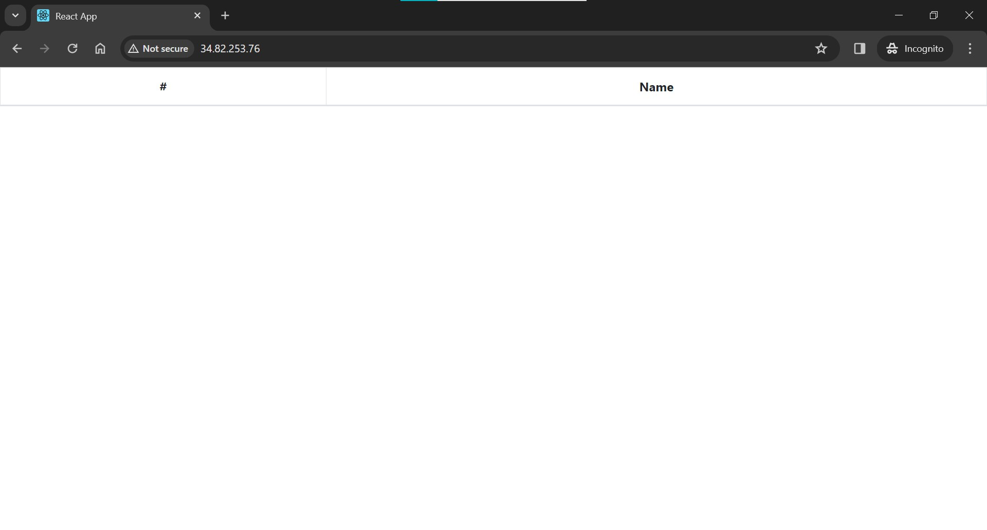

Picture name :03.bash script deployed site page

**Jenkins :**

**Installed :** Docker & docker-compose and Jenkins  
**Steps : refer document** **:** On project-submission-files folder - Configurationfiles folder - installation steps & config files are uploaded

**Login Pages :** Dev and Prod

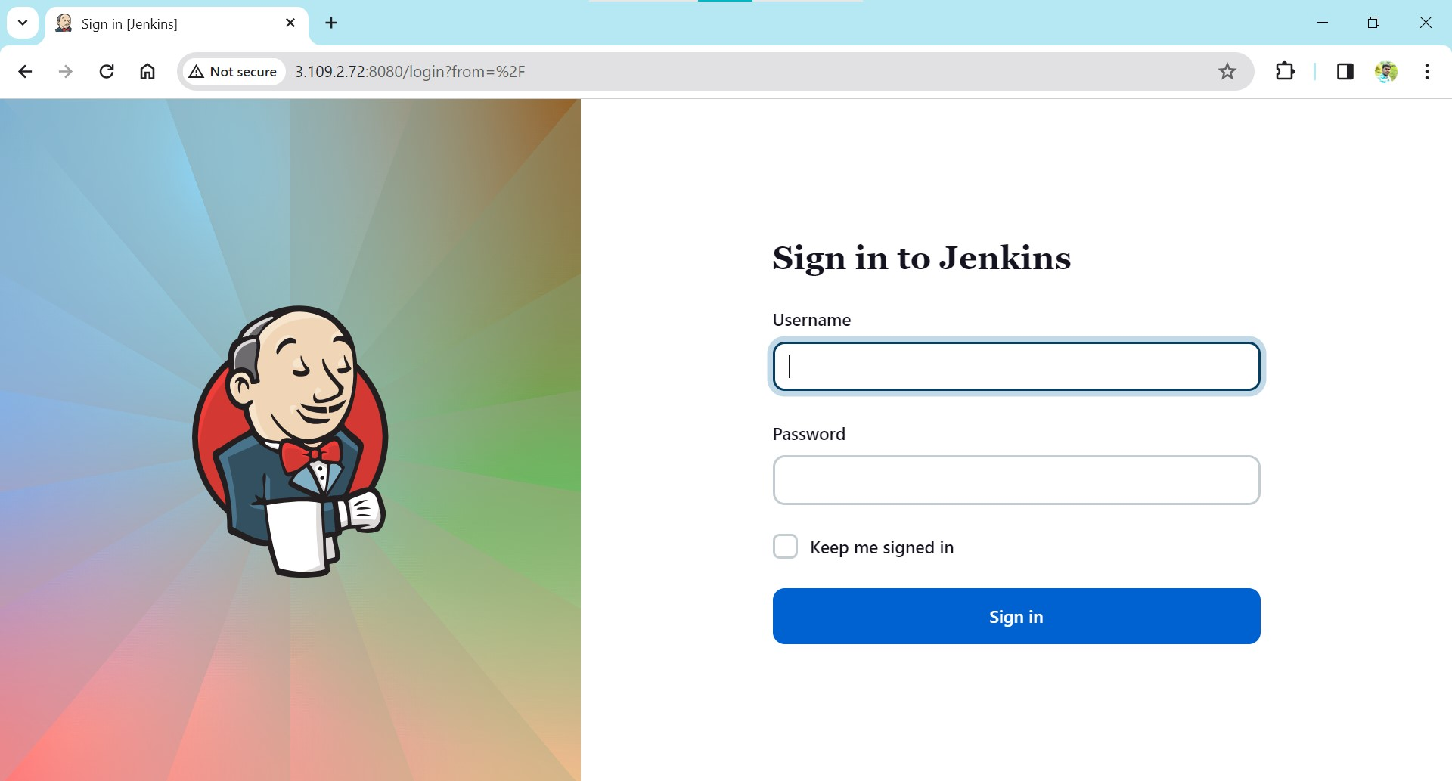

Picturename: 04.Jenkins Login Page for dev server

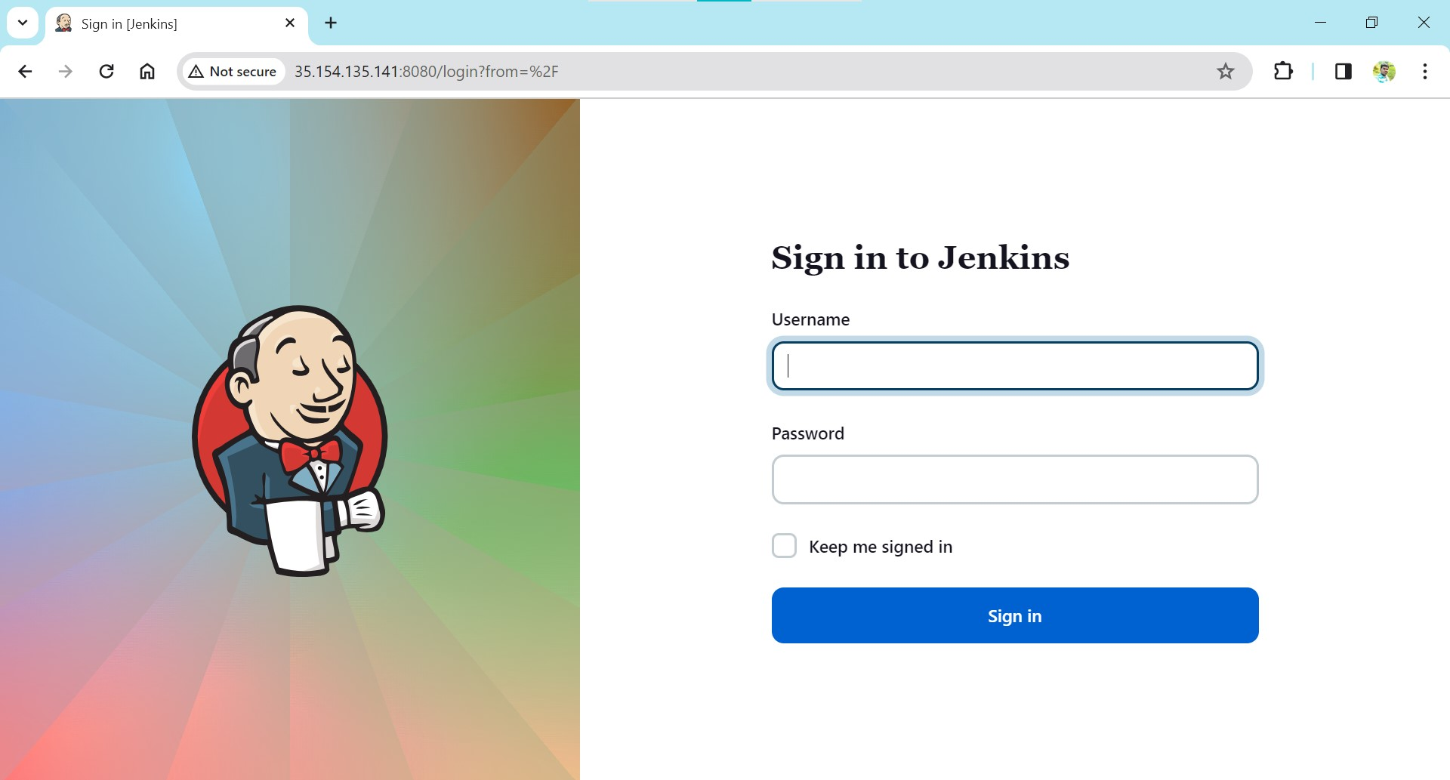

Picturename: 05.Jenkins Login Page for prod server

**Jenkins Configuration:**

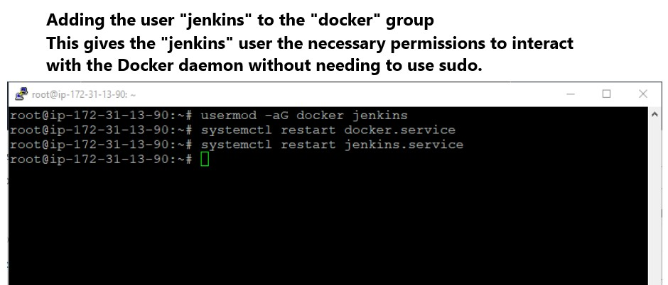

Picturename : 06.Jenkins Permission for docker

Jenkins Email configuration to trigger the success or failure from the dev and prod pipeline builds .

**mail config :**

**Smtpserver :** smtp.gmail.com

**Port :** 465

**Username :** karthisk217@gmail.com

**App password :** @@@@ #### $$$$ %%%%

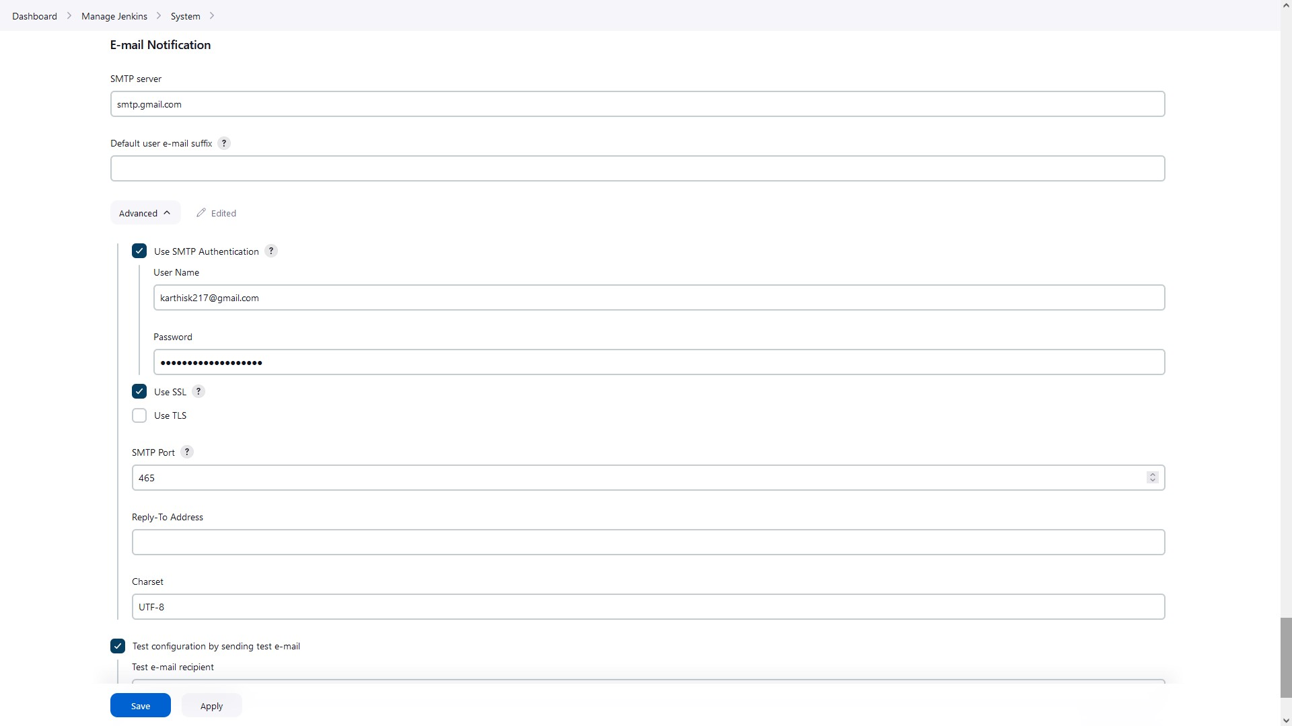: Picturename :07.Jenkins Email Configuration

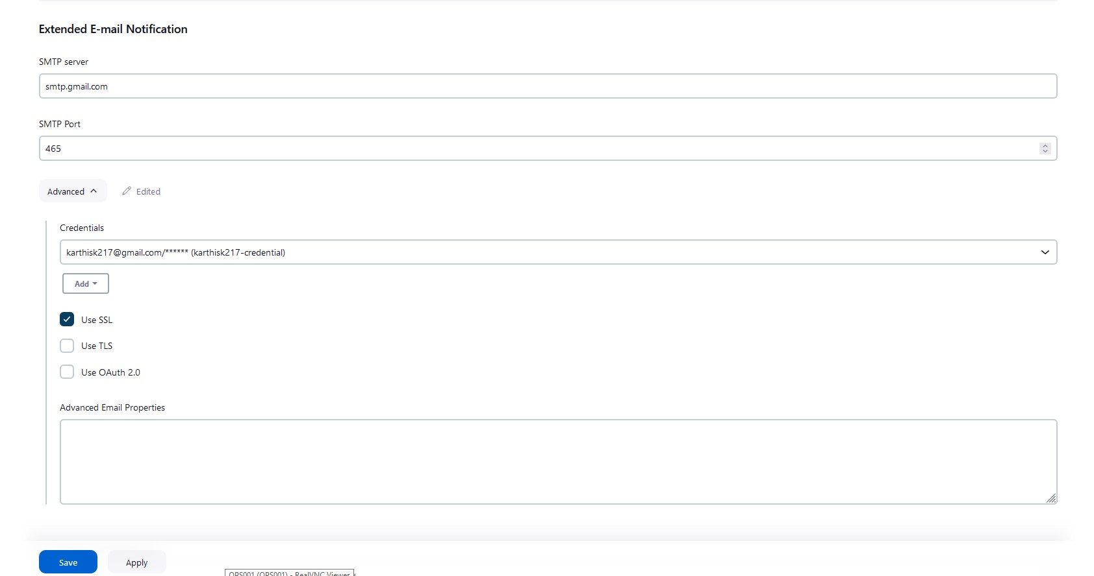

Picturename:08.Jenkins Extended email notification configuration

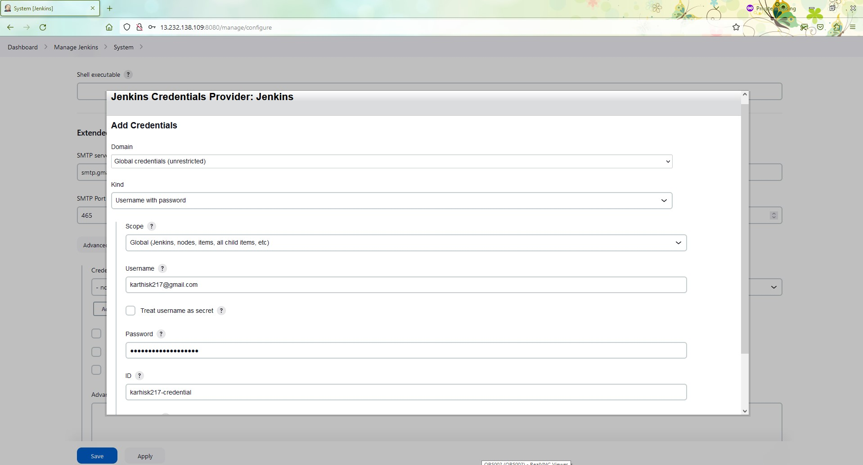

Picturename: 09.Jenkins adding gmail credential

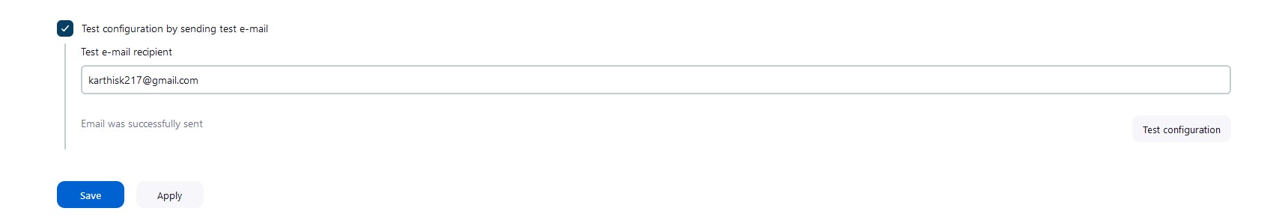

Picturename : 10.Testing Jenkins Email Configuration

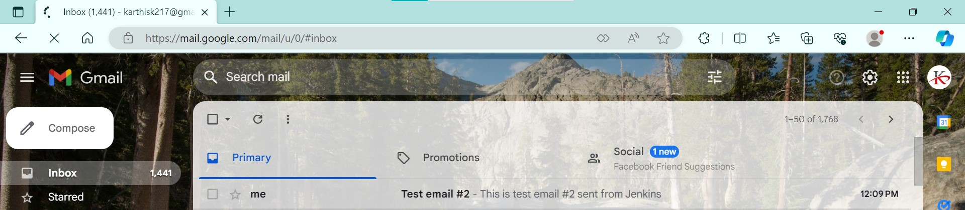

Picturename :11.Jenkins Email Configuration prod

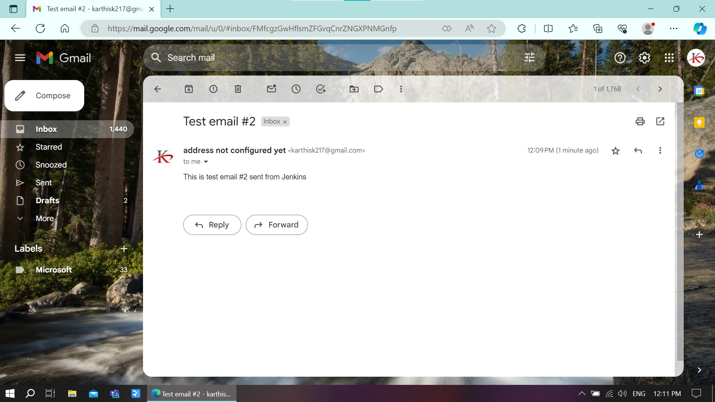

Picturename : 12.Jenkins test Inbox email

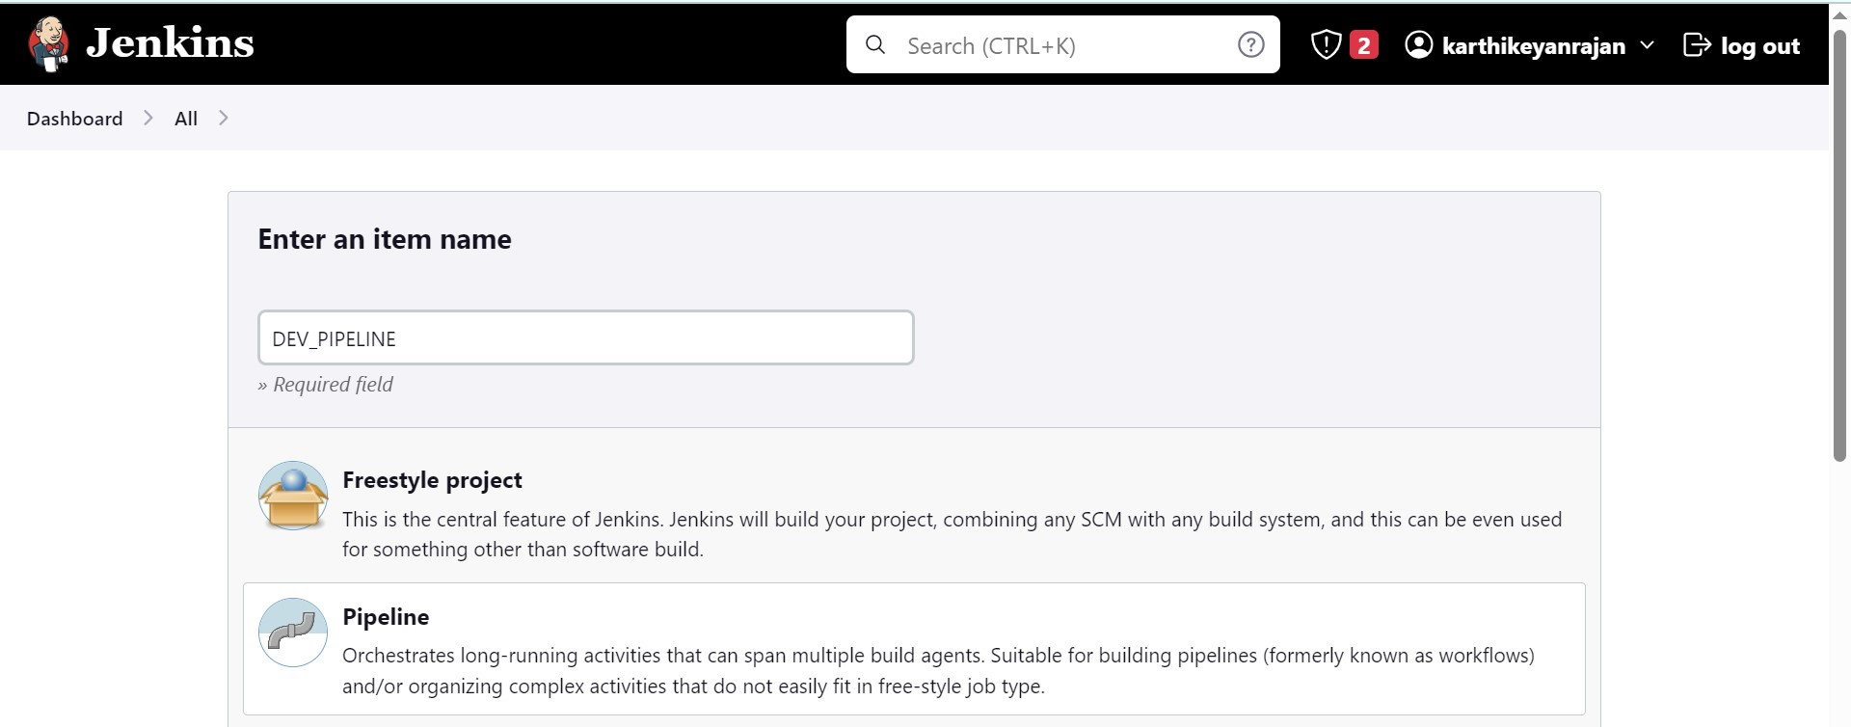

Picturename:. 13. Jenkins Pipeline configuration dev & prod

If code pushed to dev branch, docker image must build and pushed to dev repo in docker hub

Mentioned - **\*/dev (branch)**

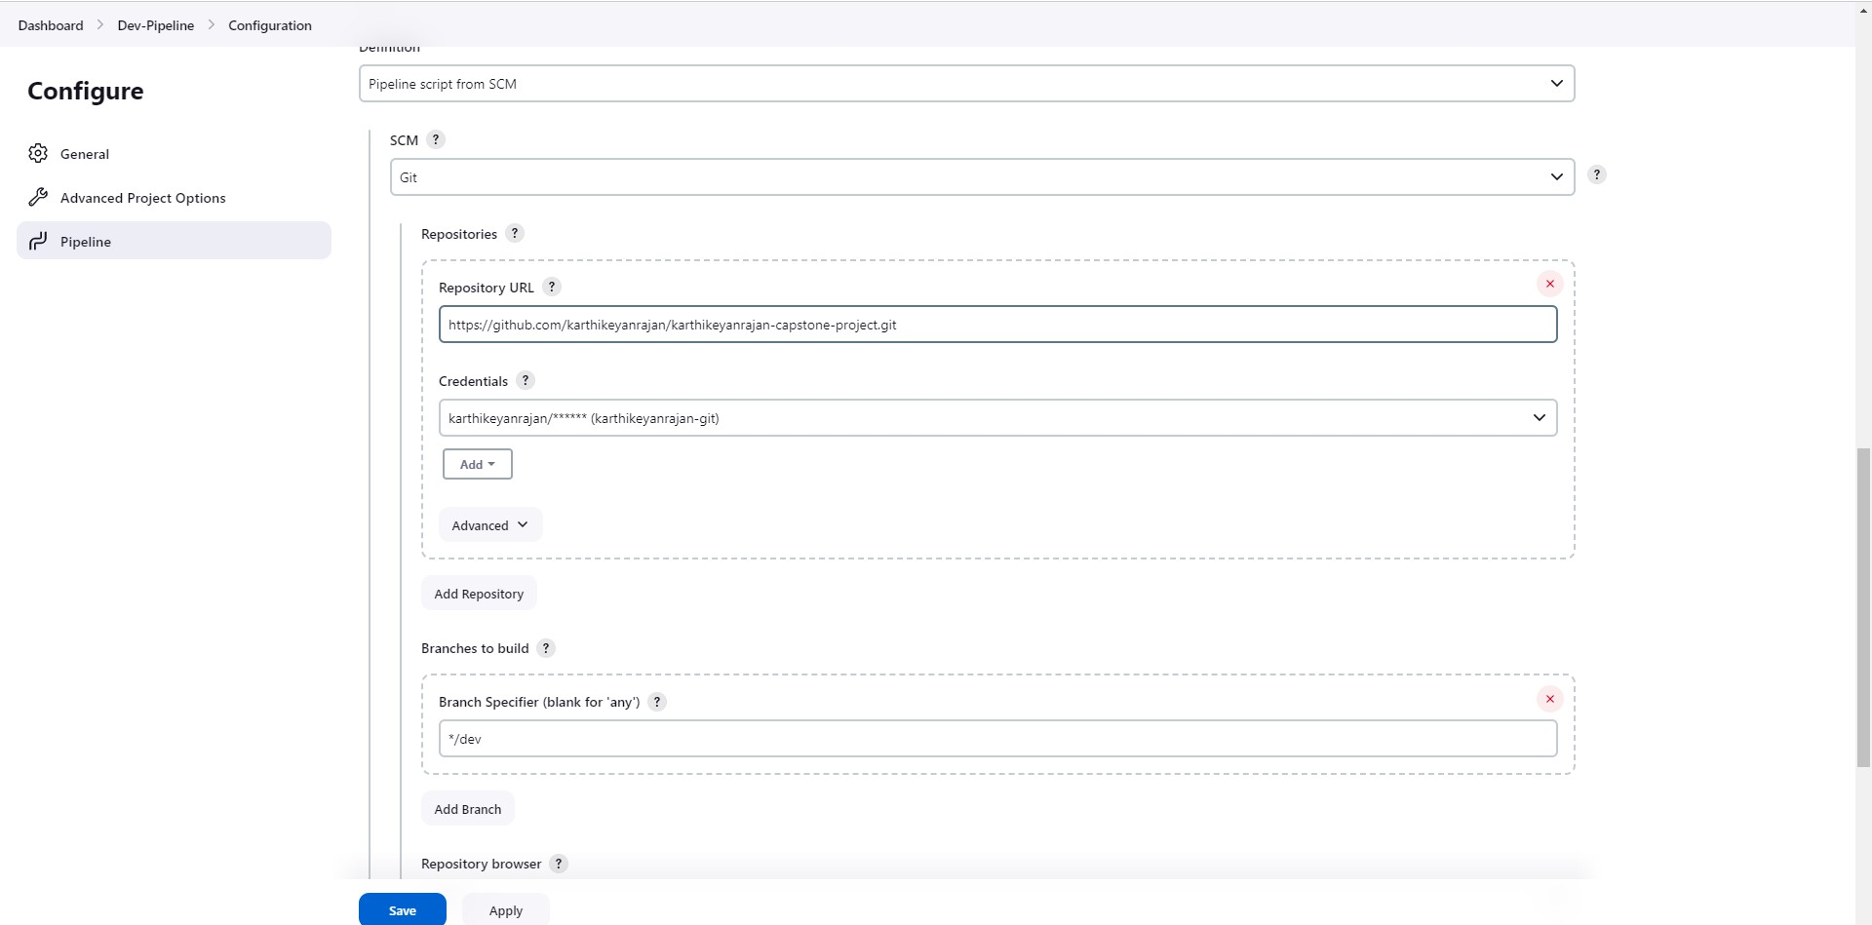

Picturename: 14.Jenkins dev pipeline config

If dev merged to master, then docker image must be pushed to prod repo in docker hub  
Mentioned - **\*/master (master branch)**

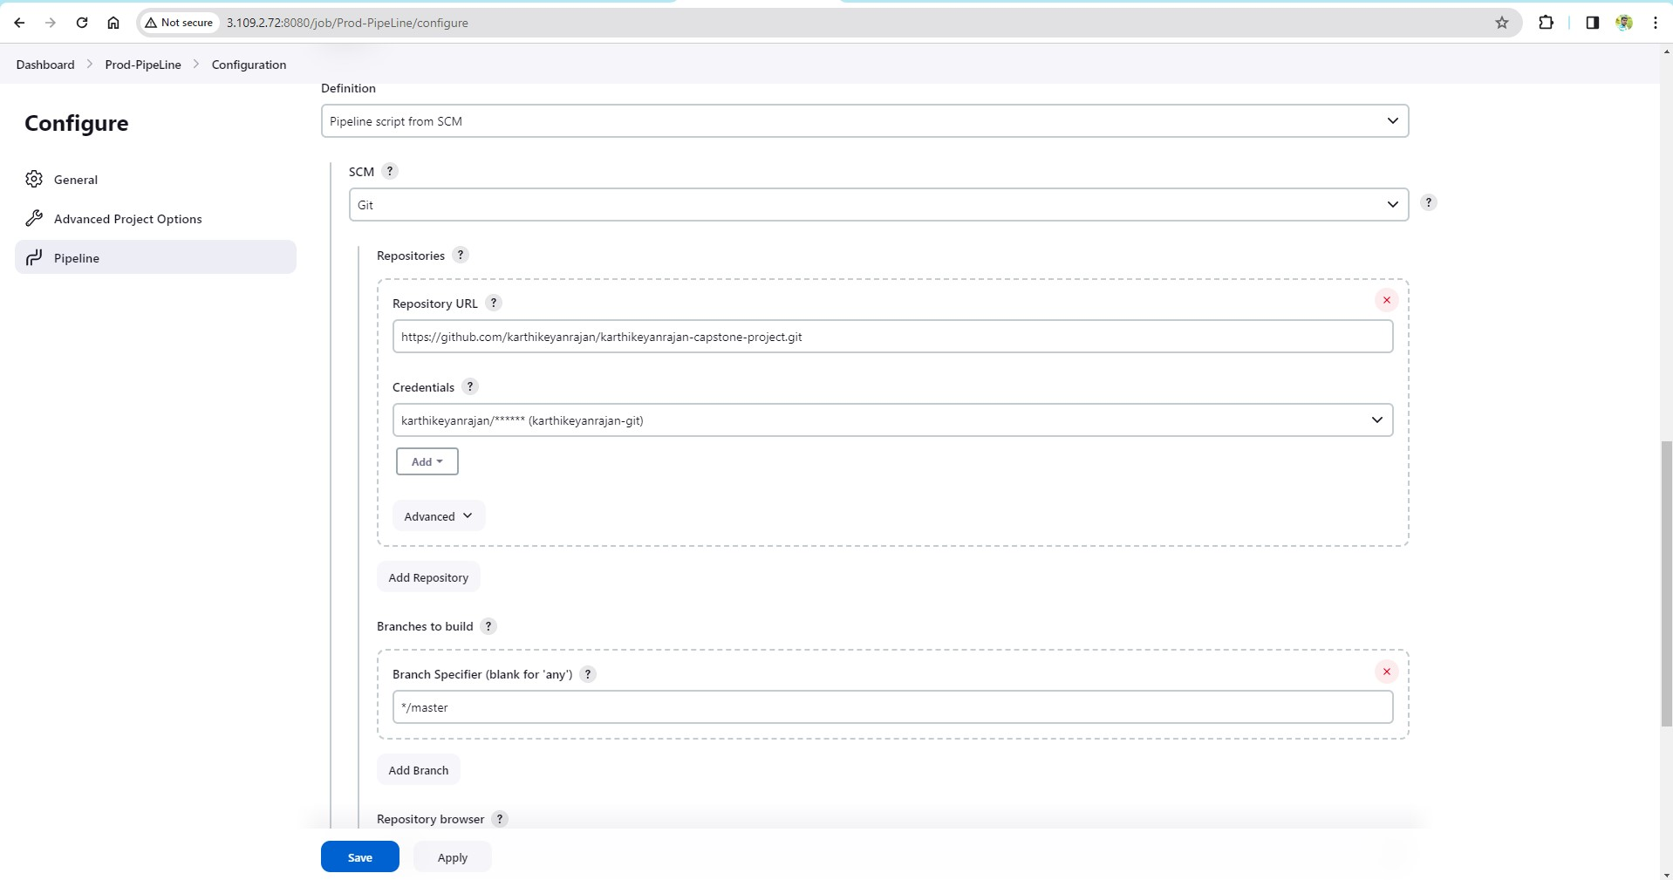

Picturename: 15.Jenkins Prod PipeLine config

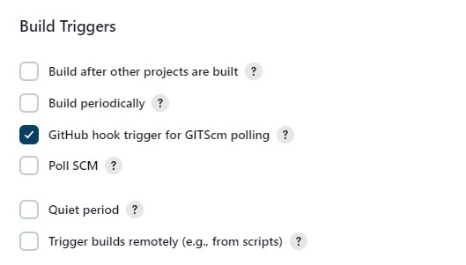

Picturename: 16.Jenkins build trigger scm polling

Connected Github repo with auto build trigger from both dev & master branch

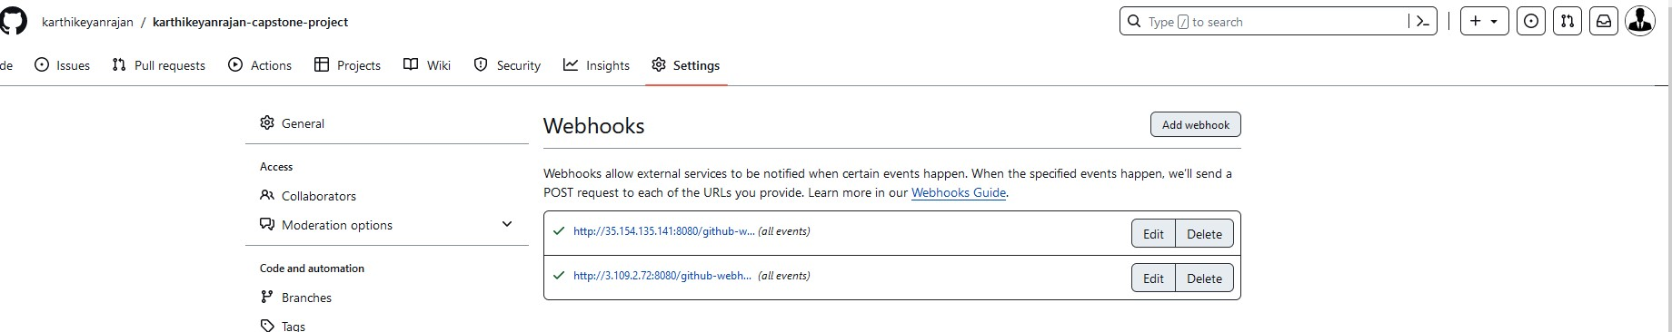

Picturename: 17.Jenkins webhook config git

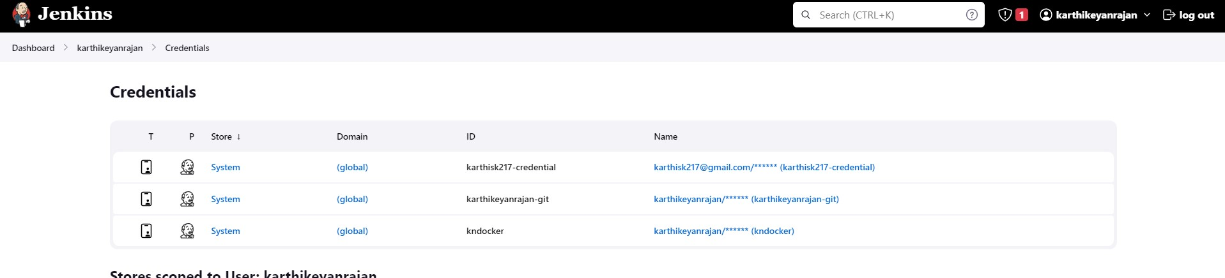

Picturename: 18.Jenkins - Docker ,git ,mail credentials

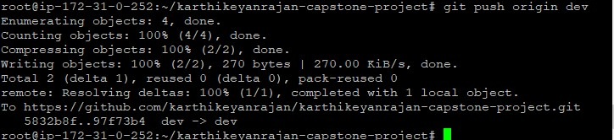

Picturename:19.Jenkins_changes in dev branch

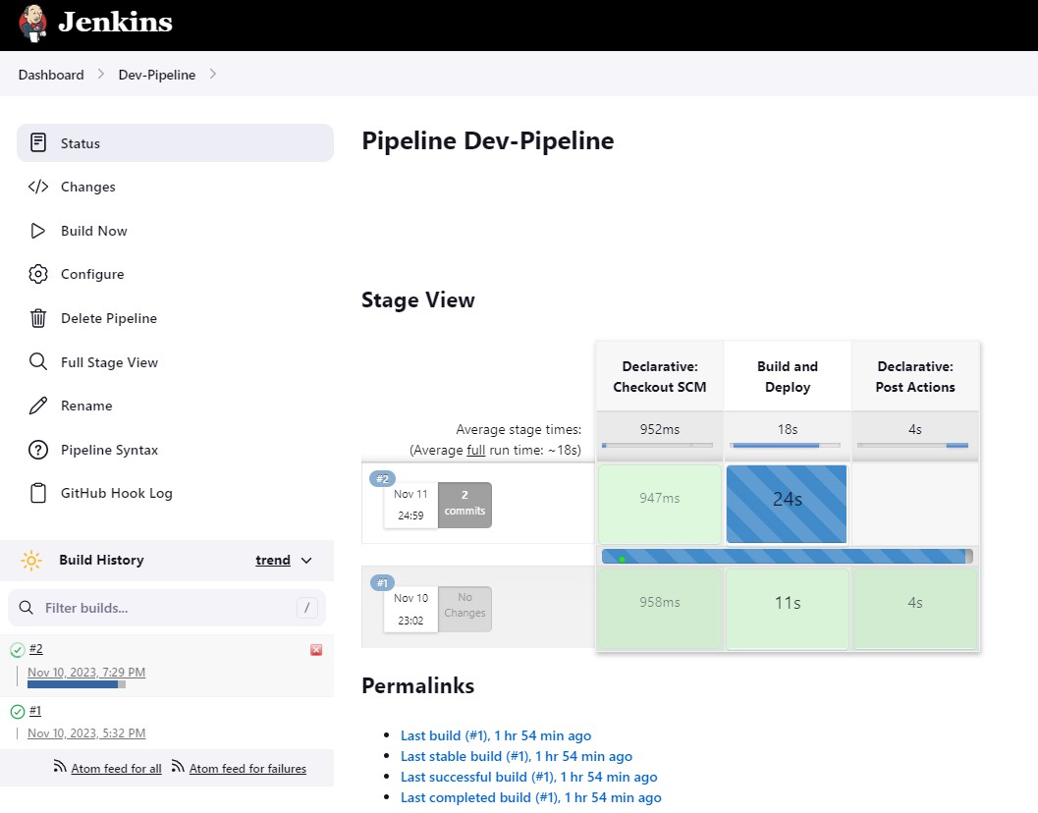

Picturename: 20.Jenkins dev Build trigger by webhook

**For the success or failure build will get email for both the branches dev and master with the attached logs**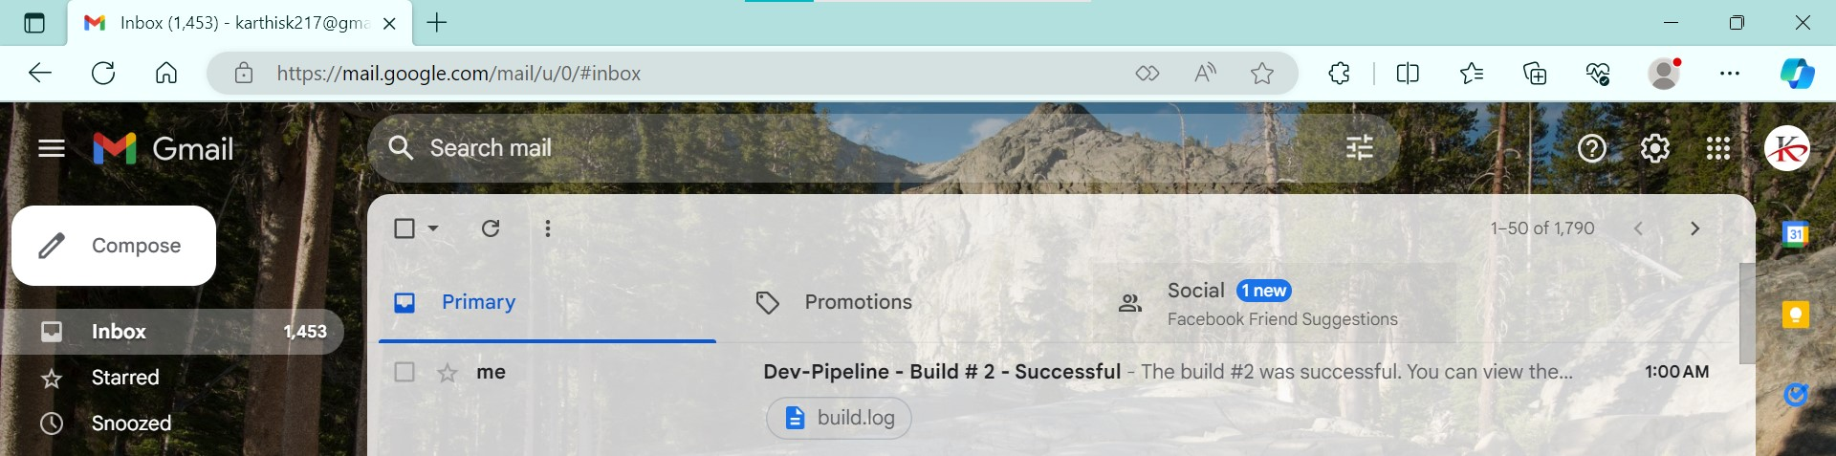

Picturename: 21.Jenkins dev build success mail with attached logs

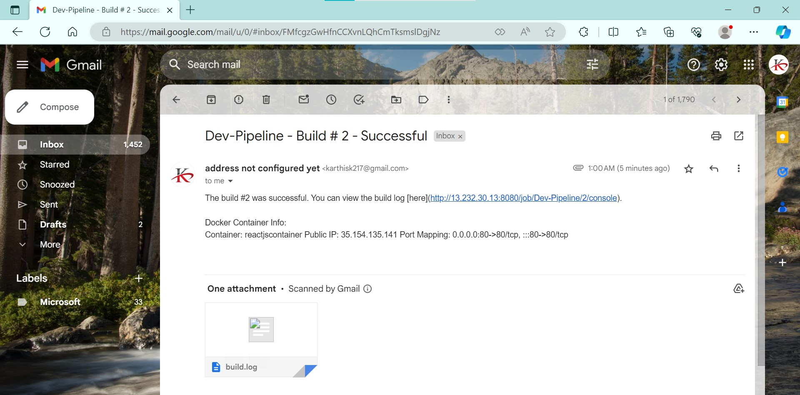

Picturename: 22.Jenkins dev build inbox email with log

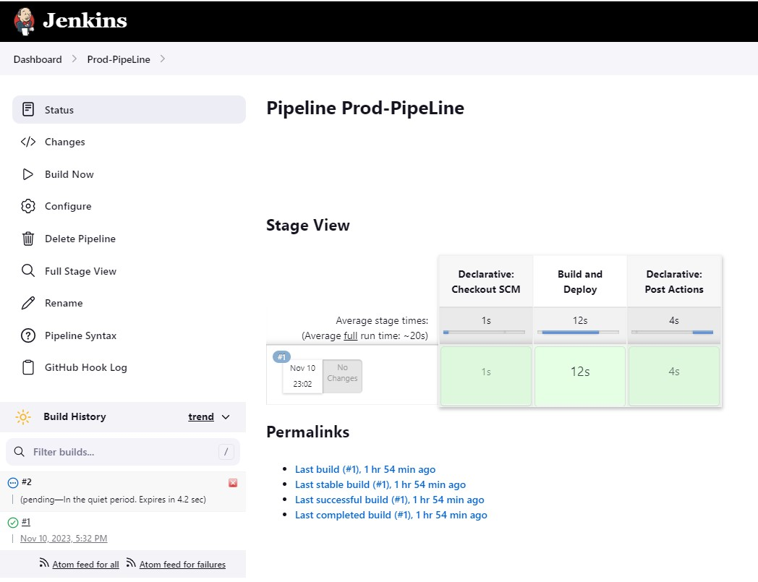

Picturename: 23.Jenkins prod Build trigger by webhook

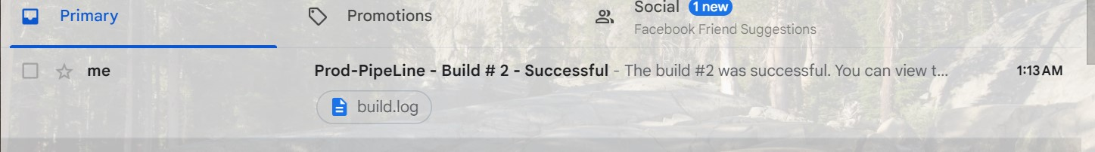

Picturename:24.Jenkins prod build success image

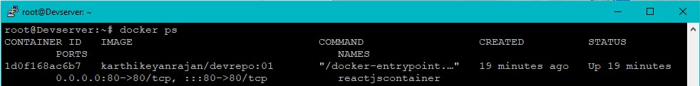

Picturename: 25.Jenkins dev image container

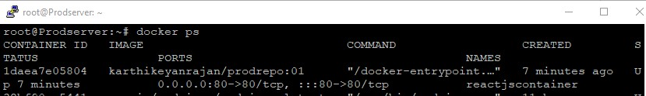

Picturename :26.Jenkins Prod Image container

**For Jenkins - execute step commands - Please refer the Jenkins file in my github repo main branch**

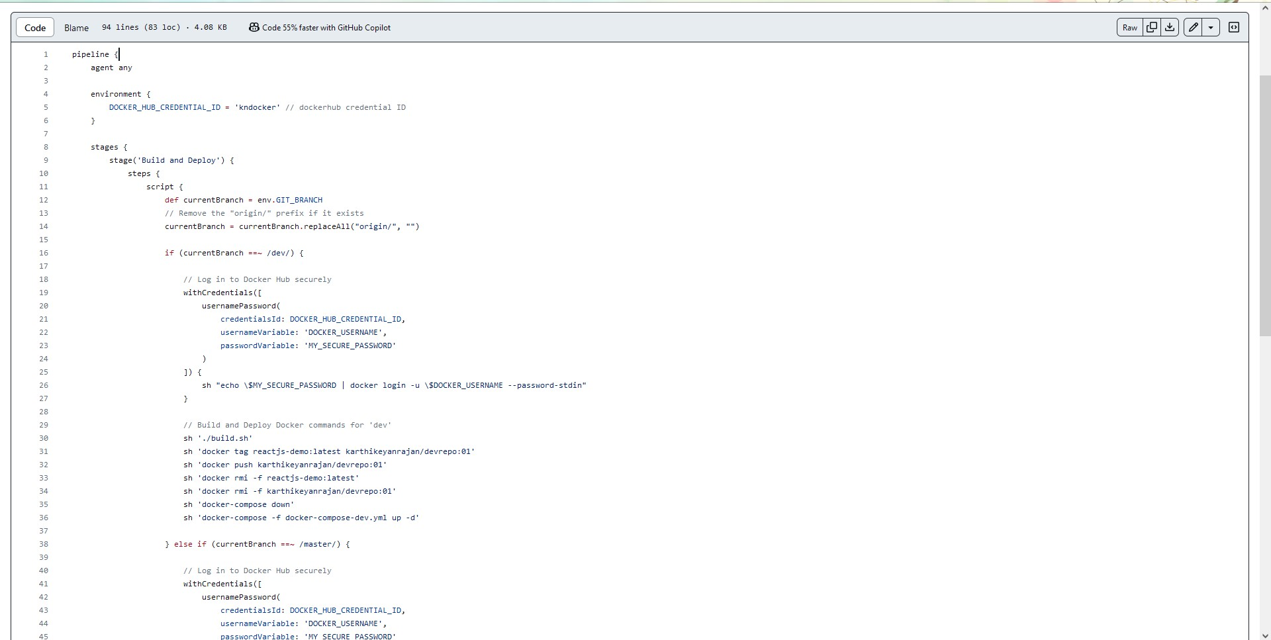

Picturename :27.Jenkins file steps screenshot

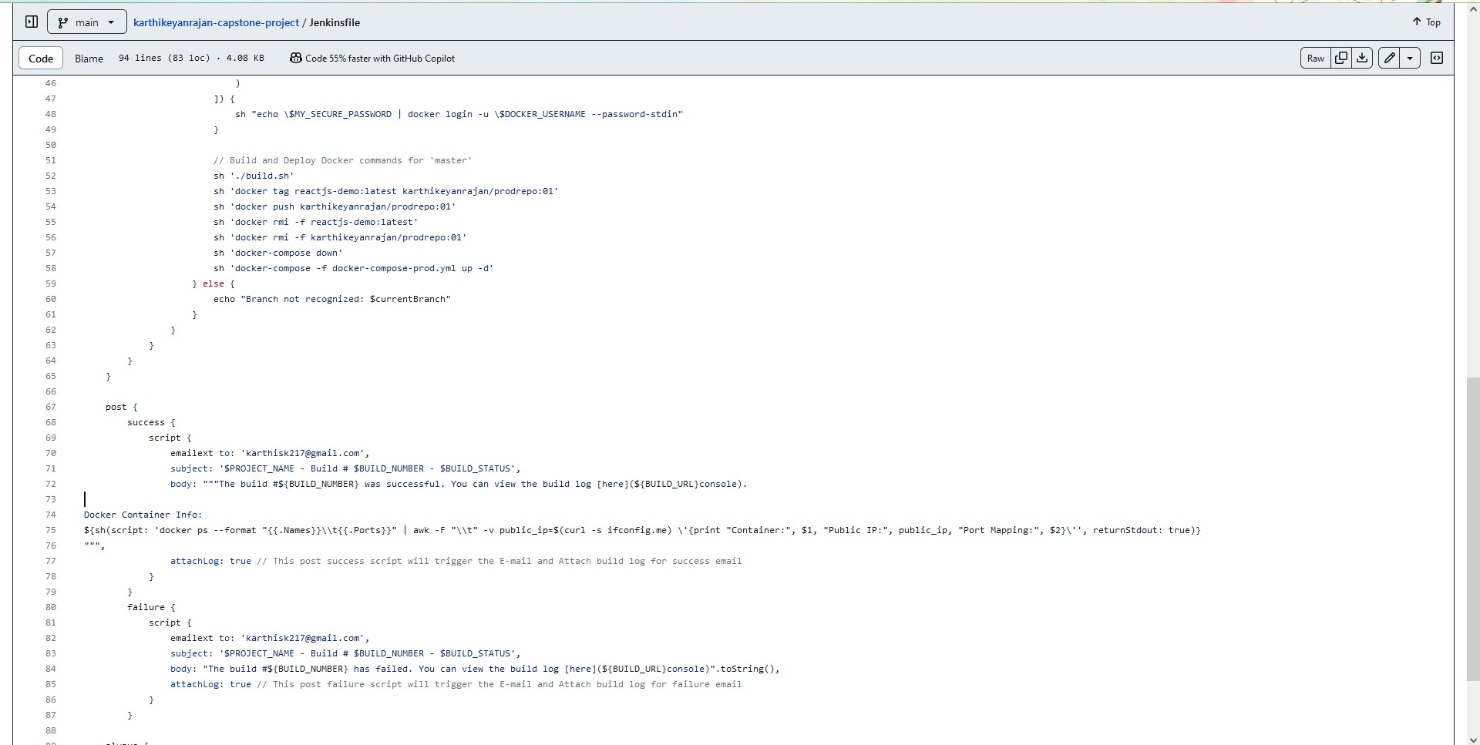

Picturename :28.Jenkins file steps screenshot2

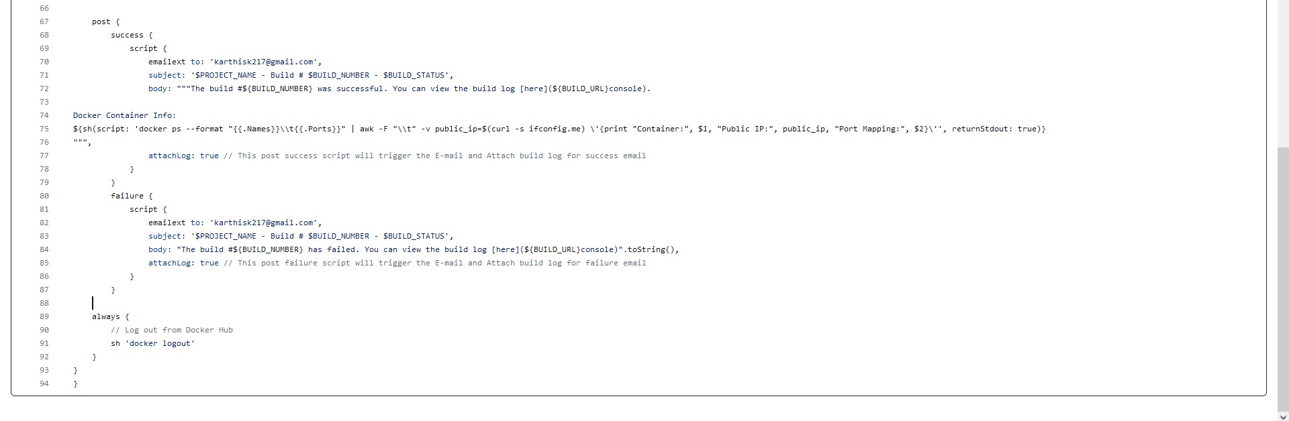

Picturename : 29.Jenkins file steps screenshot3

***AWS console :***

**Karthikeyanrvm -** From outside user need to login to this vm and SSH enabled only from this instance to Monitoring, Dev, Prod Servers.

**Monitoring Server -** Loaded with prometheus,grafana,alertmanager to monitor Dev, Prod Servers

**Dev Server -** Loaded with Nodeexporter, docker & docker-compose , Jenkins, cadvisor

(container advisor to get metrics from the docker containers)

**Prod Server -** Loaded with Nodeexporter, docker & docker-compose , Jenkins, cadvisor

(container advisor to get metrics from the docker containers)

Whoever has the ip address can access the reactjs application output ( from the web)

Login to server can should be made only from **Karthikeyanrvm**

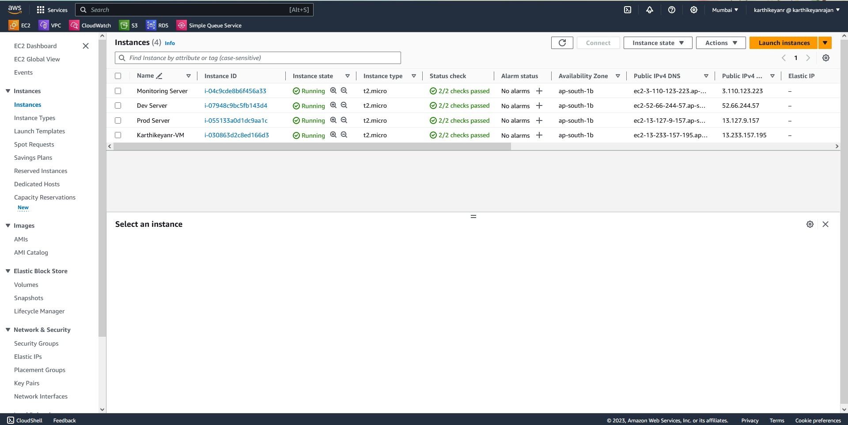

Picturename:30.AWS consoles and instances  
The above picture :  
Monitoring Server, Dev server and prod server and karthikeyanrvm are running

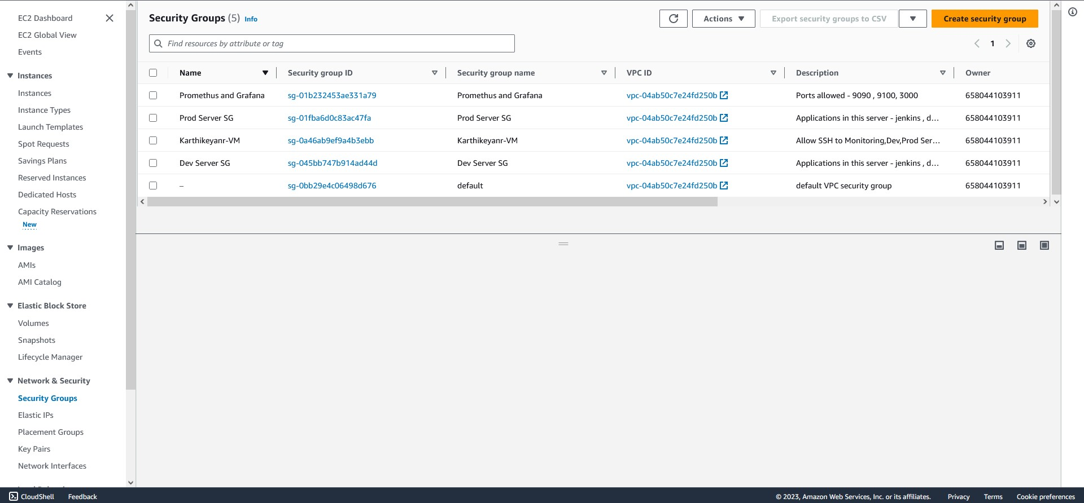

Picturename:31.AWS SG's

The above picture :

Sg’s for all Monitoring Server, Dev server andprod server and karthikeyanrvm

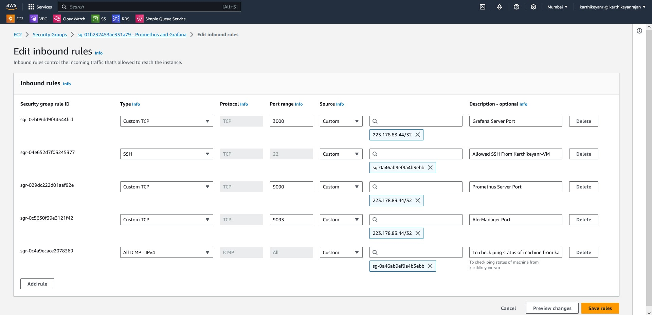 Picturename: 32 .AWS SG - monitoring server -promethus and grafana

The above picture:

223.178.83.44/32 - allowed from outside user machine ip

sg-0a46ab9ef9a4b3ebb - Karthikeyanr-VM - ssh allowed from Karthikeyanr-VM instance

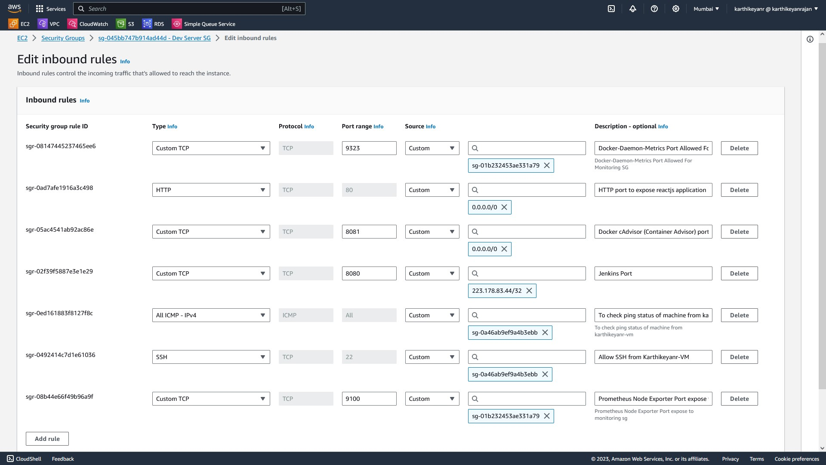

Picturename:33.AWS SG - Dev server

The above picture:

223.178.83.44/32 - allowed from outside user machine ip

sg-0a46ab9ef9a4b3ebb - Karthikeyanr-VM - ssh allowed from Karthikeyanr-VM instance

sg-01b232453ae331a79 - Promethus and Grafana - ports allowed access only for monitoring server

0.0.0.0/0 - ipv4 allow from any IP

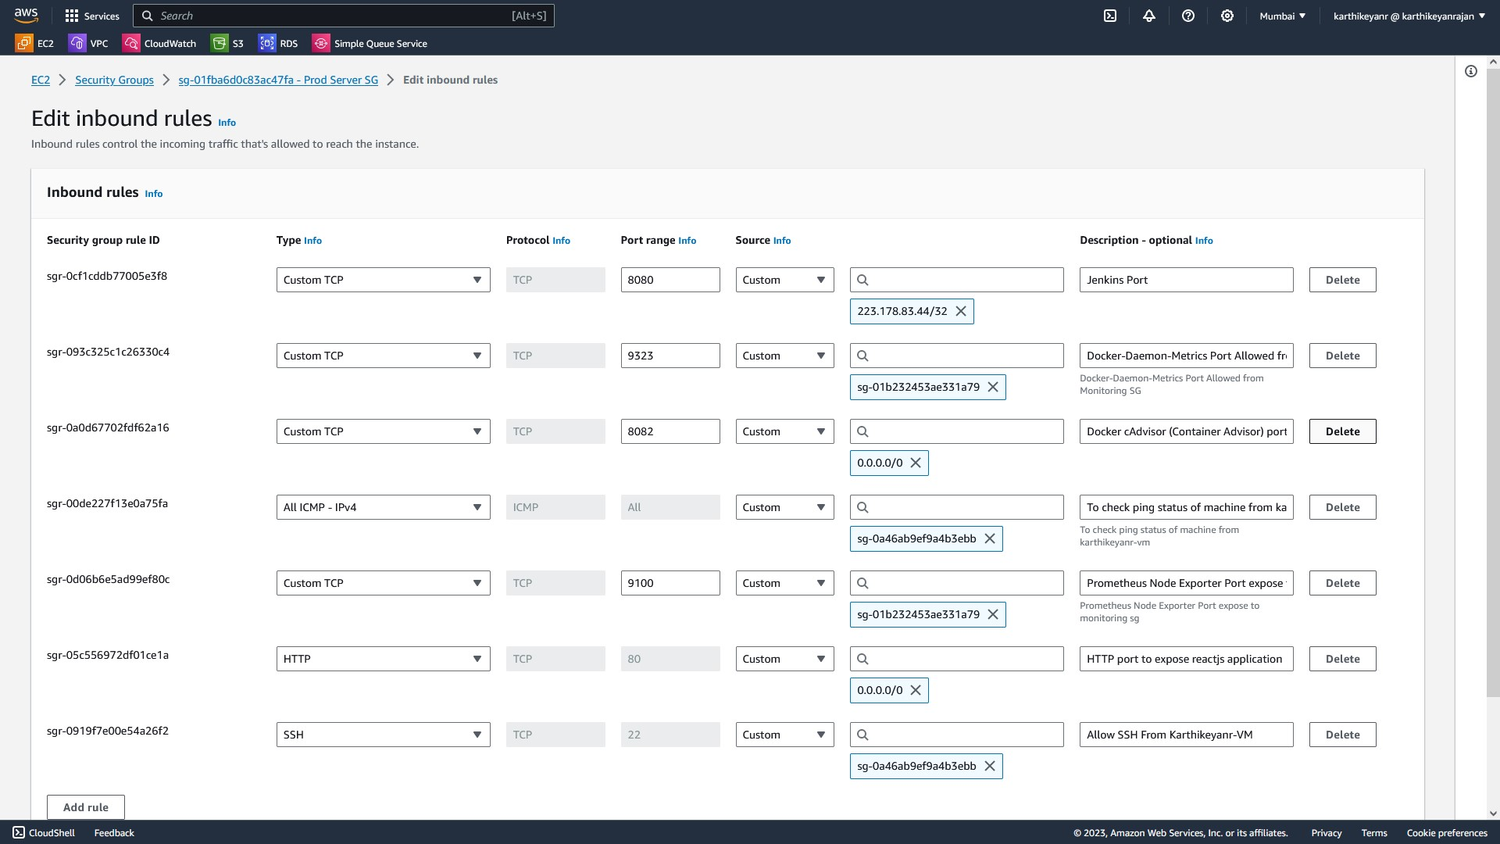

Picturename:34.AWS SG - Prod server

The above picture:

223.178.83.44/32 - allowed from outside user machine ip

sg-0a46ab9ef9a4b3ebb - Karthikeyanr-VM - ssh allowed from Karthikeyanr-VM instance

sg-01b232453ae331a79 - Promethus and Grafana - ports allowed access only for monitoring server

0.0.0.0/0 - ipv4 allow from any IP

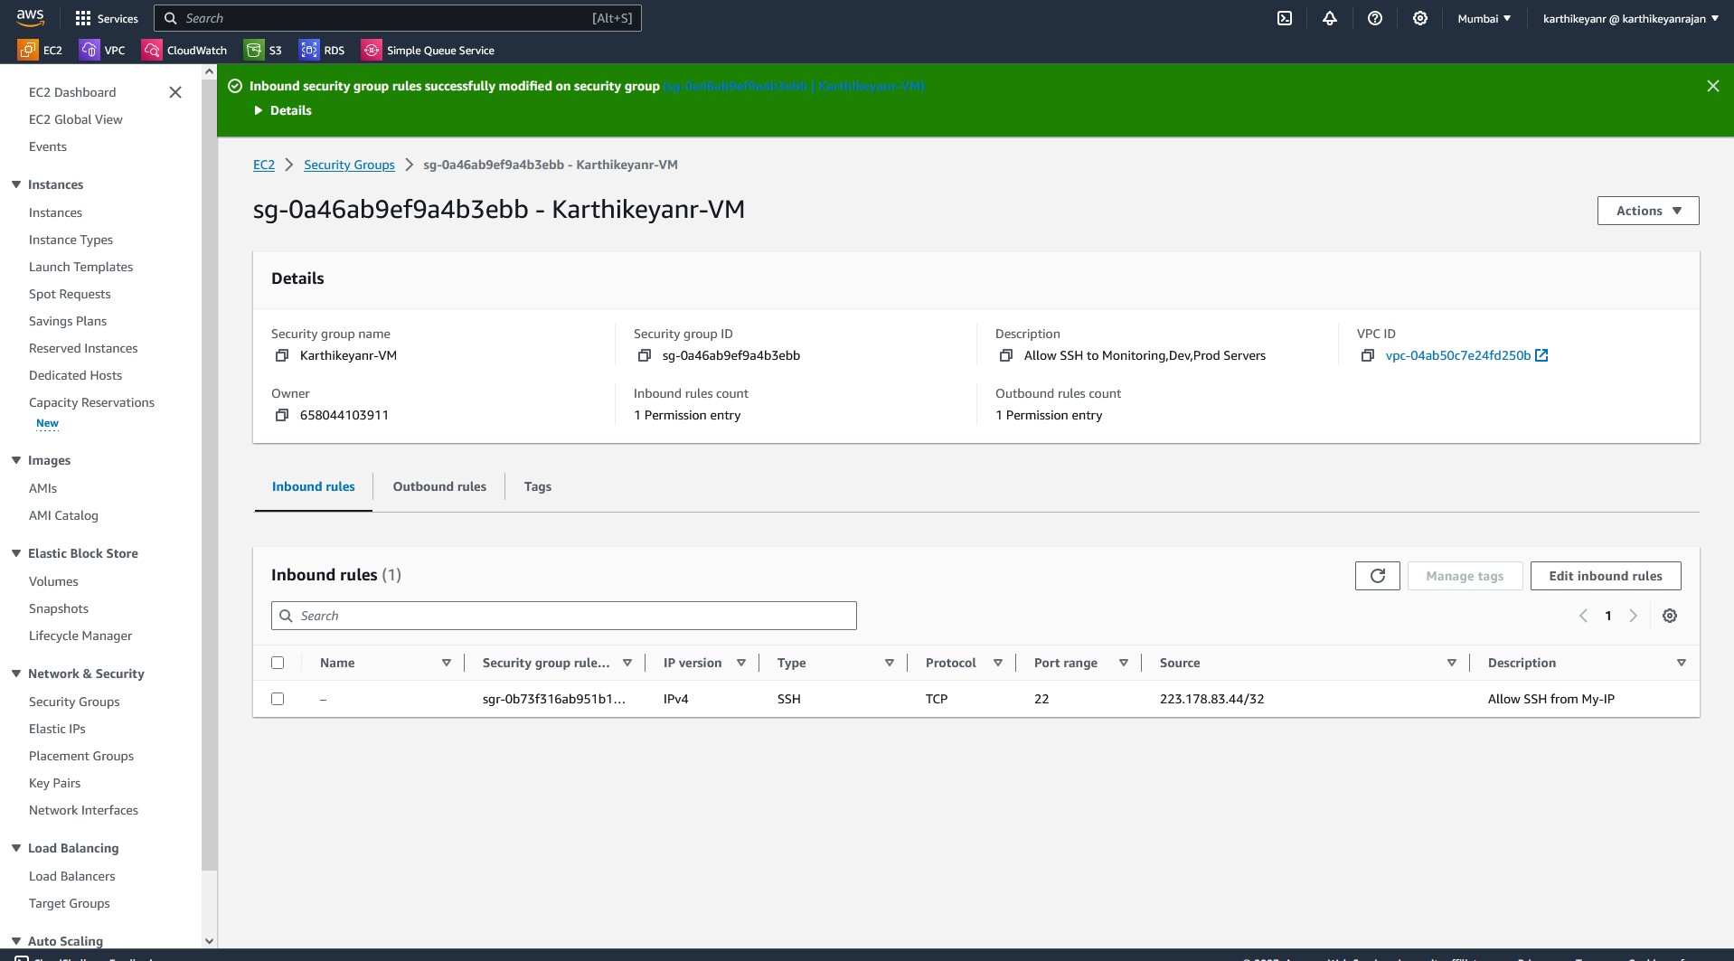

Picturename:35.AWS SG - Karthikeyanrvm

223.178.83.44/32 - allowed ssh from outside myip

SSH to the Monitoring server , Dev server , prod server allowed only form this karthikeyanr-vm instance via private ip of the servers

No other from outside able to ssh into Monitoring server , Dev server , prod server

***DockerHub:***

Here is Dockerhub registries for the -karthikeyanrajan/devrepo(public) & karthikeyanrajan/prodrepo(private)  
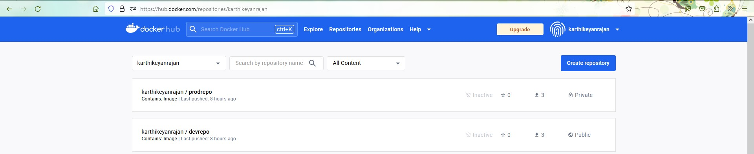

Picturename:36.Dockerhub repos prod(private) and dev(public)

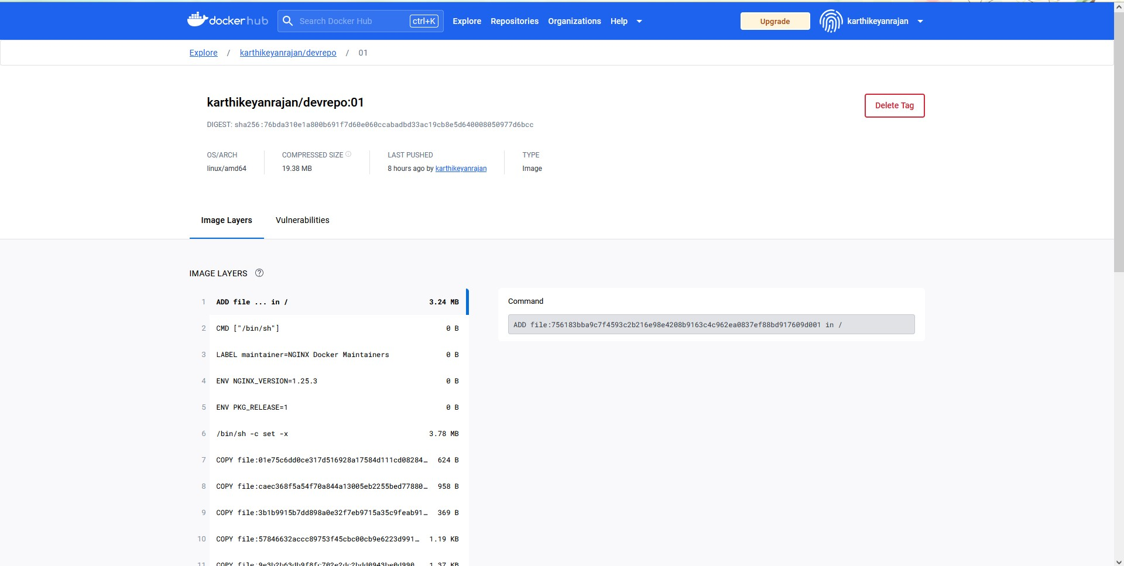

Picturename:37.Dockerhub repo dev(public)

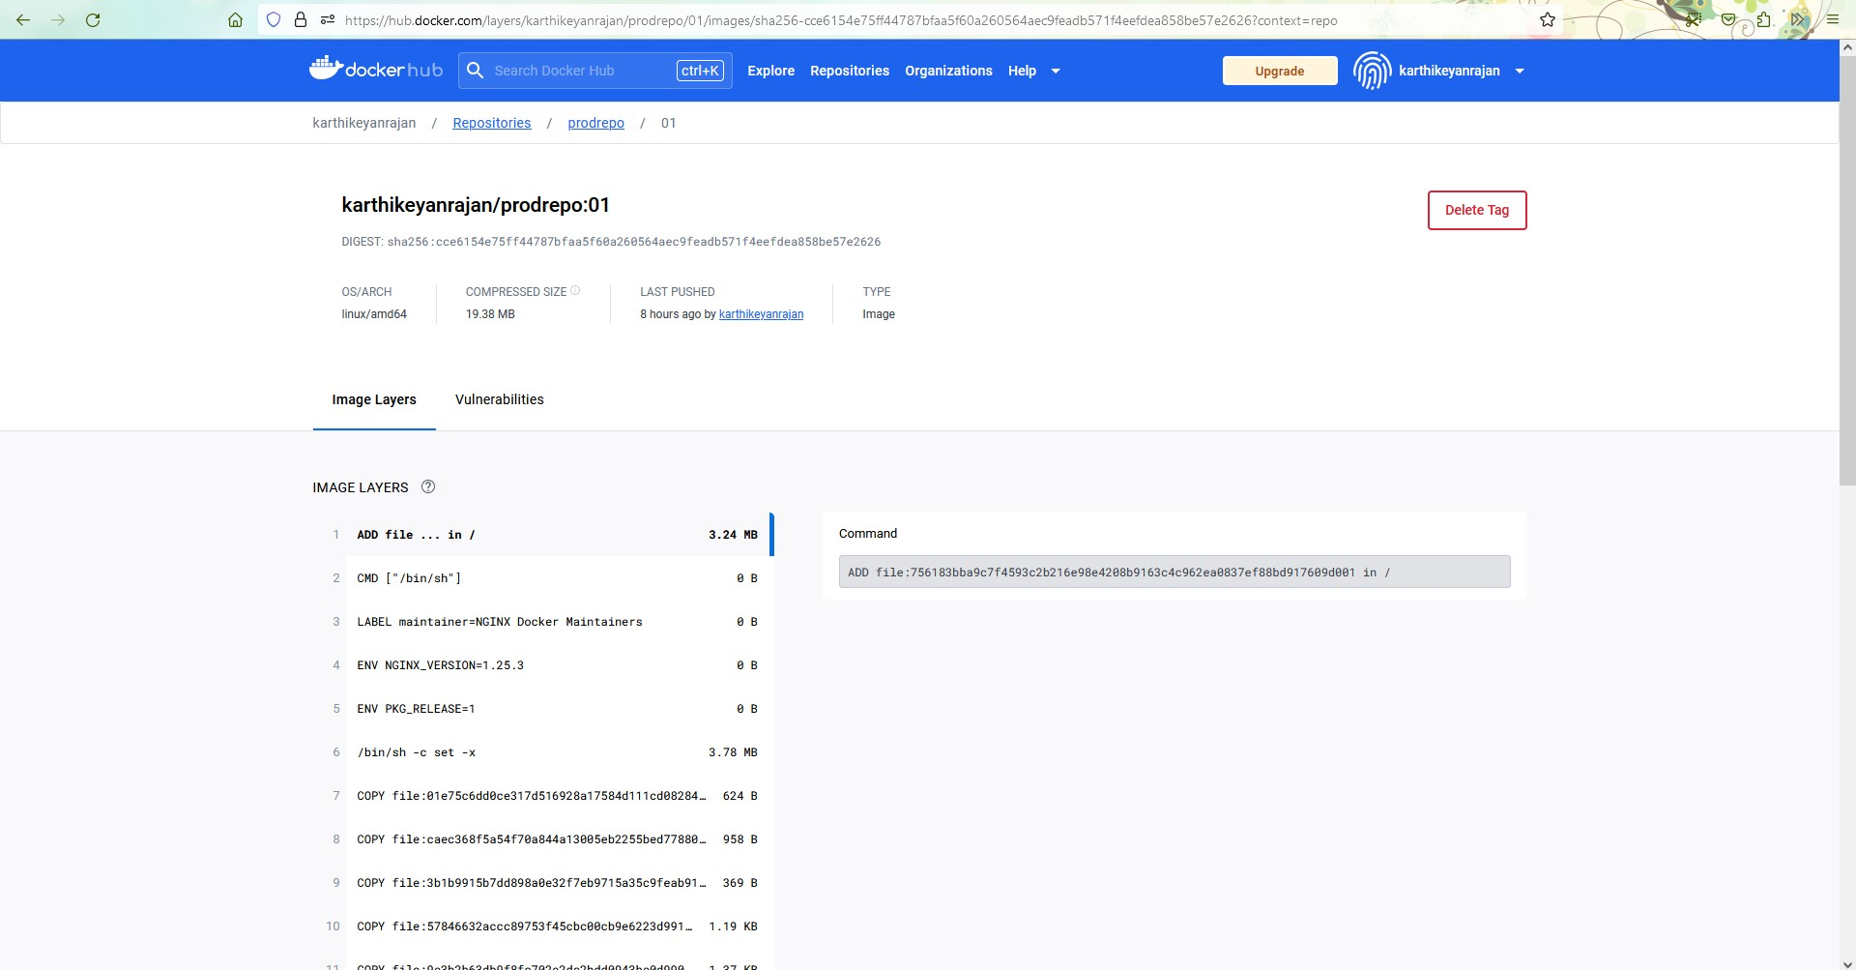

Picturename:38.Dockerhub repos prod(private)

**Deployed Page By using Docker Images :**

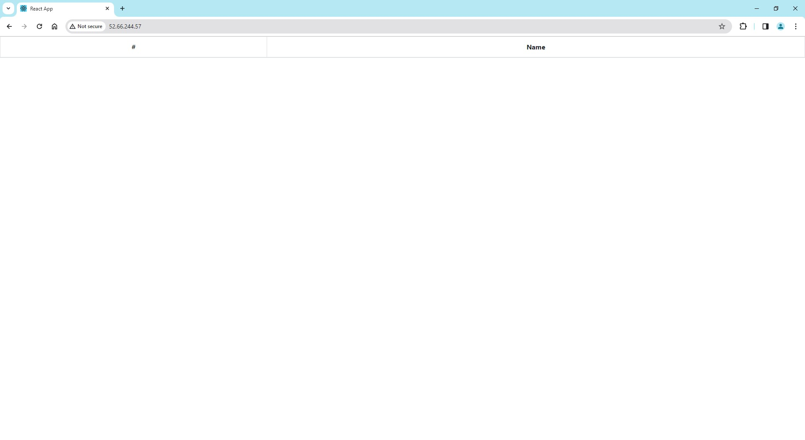  
Picturename:39.Dockerhub devrepo image deployed site

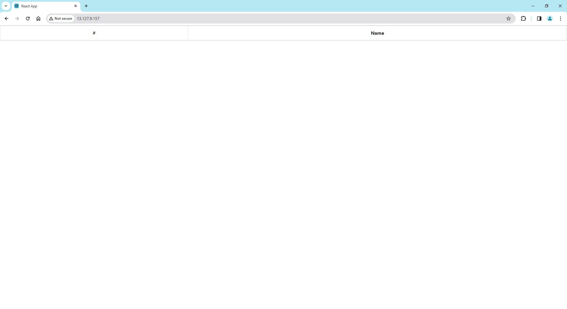

40.Dockerhub prod repo image deployed site

***Monitoring:***

***Outputs from the monitoring server:***

Configuration files are shared in the repo  
On project-submission-files folder - Configurationfiles folder - installation steps & config files are uploaded regarding jenkins

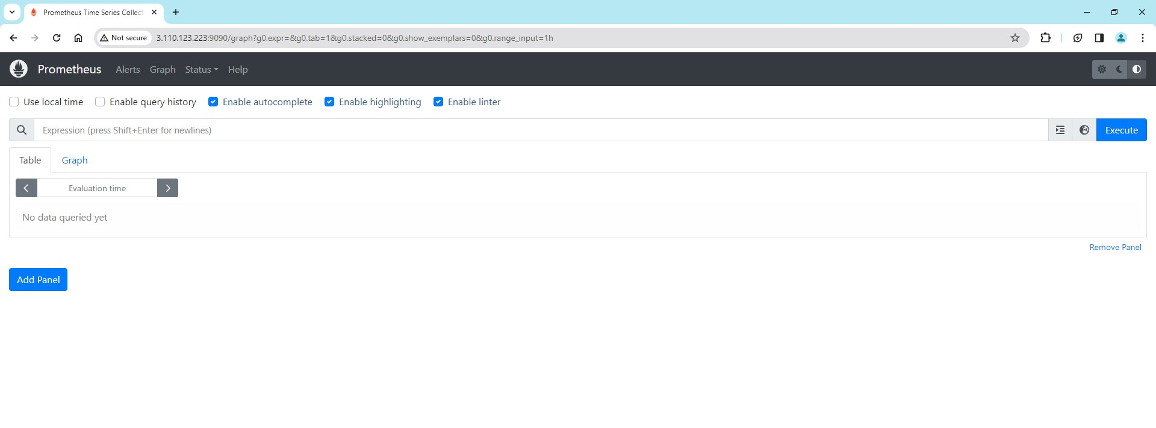

Picturename:41.Prometheus UI

Peomethus alerts will trigger and sent via email   
HostDown alert , Highcpu alert and high memory alert on promethus

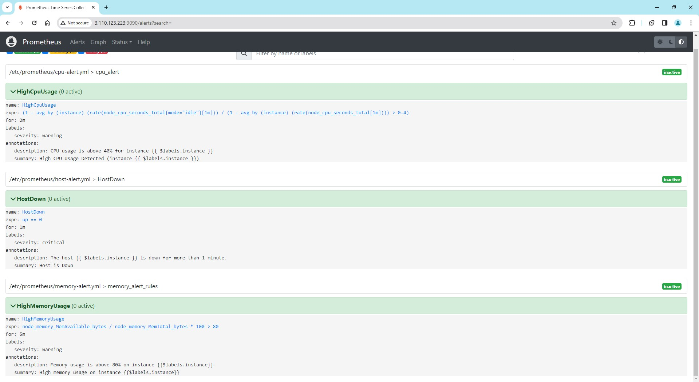

Picturename: 42.Prometheus UI configured alerts

Configured Targets for:

Dev and Prod - NodeExporter to get machine metrics

Dev and Prod - dockermetrics (from daemon.json) to get docker engine metrics

Dev and Prod - cadvisormetrics to get containers metrics

Monitoring server - localhost ( self )

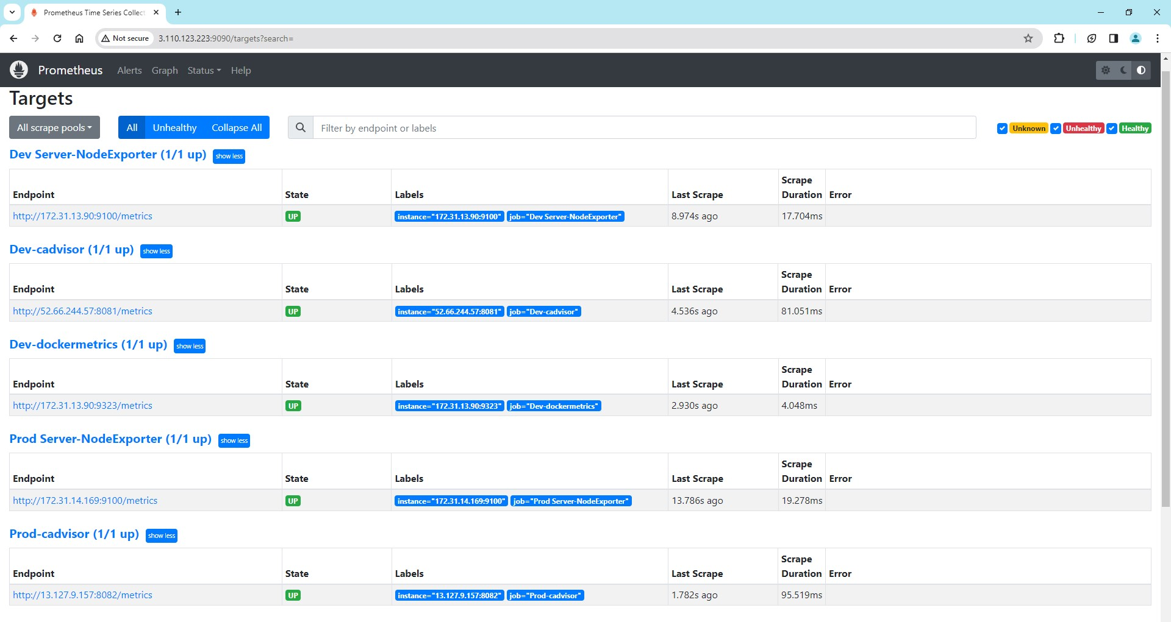

Picturename: 42.Prometheus UI configured targets UP (1)

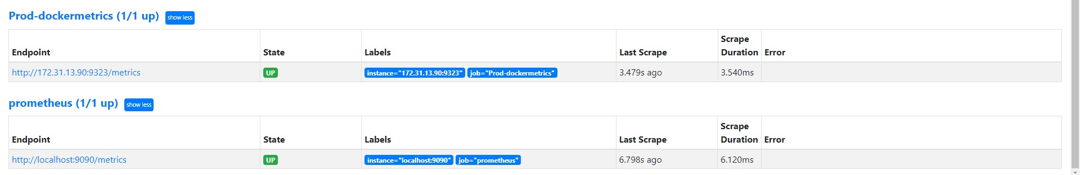

Picturename: 43.Prometheus UI configured targets UP(2)

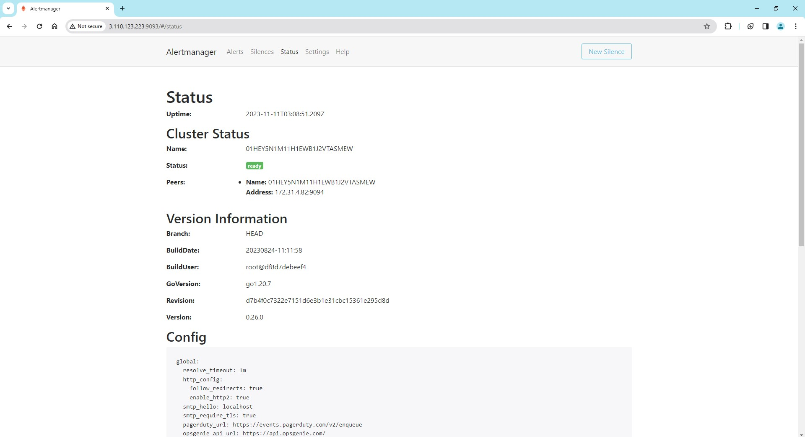

Picturename: 44.Alertmanager

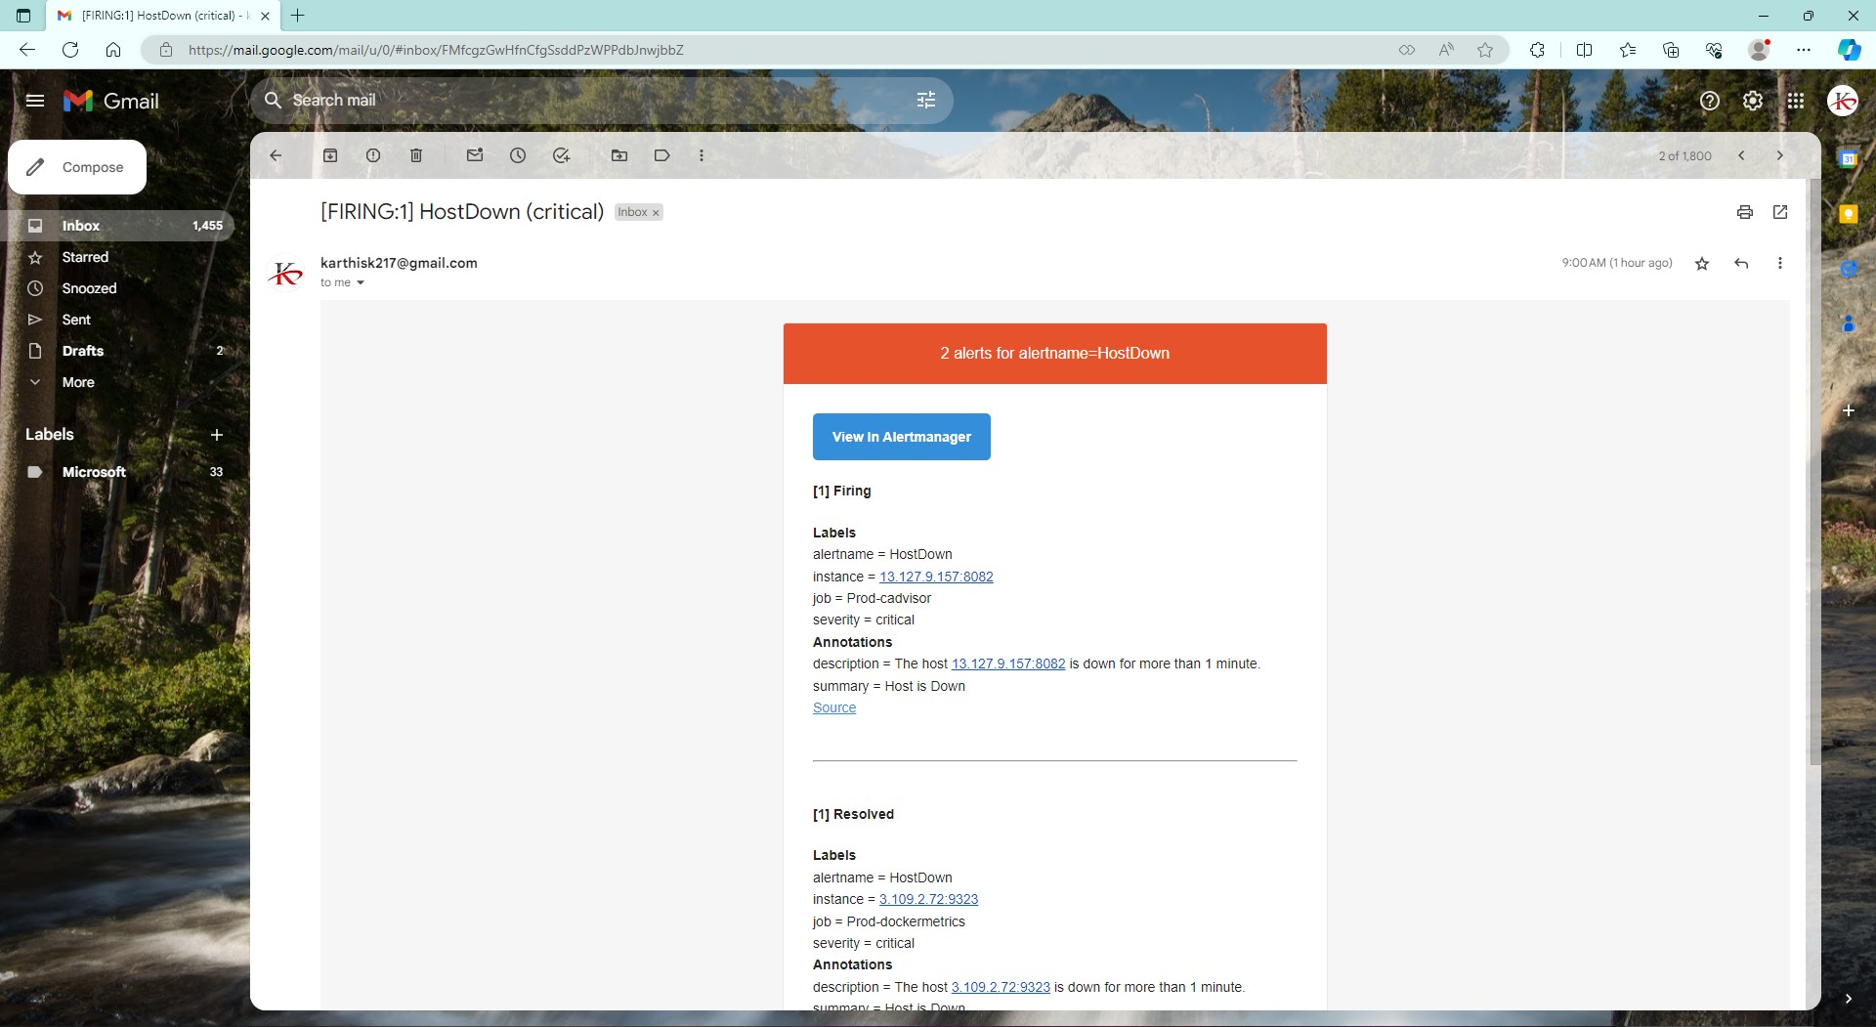

Picturename: 45.Alertmanager email notifcations for the configured alerts

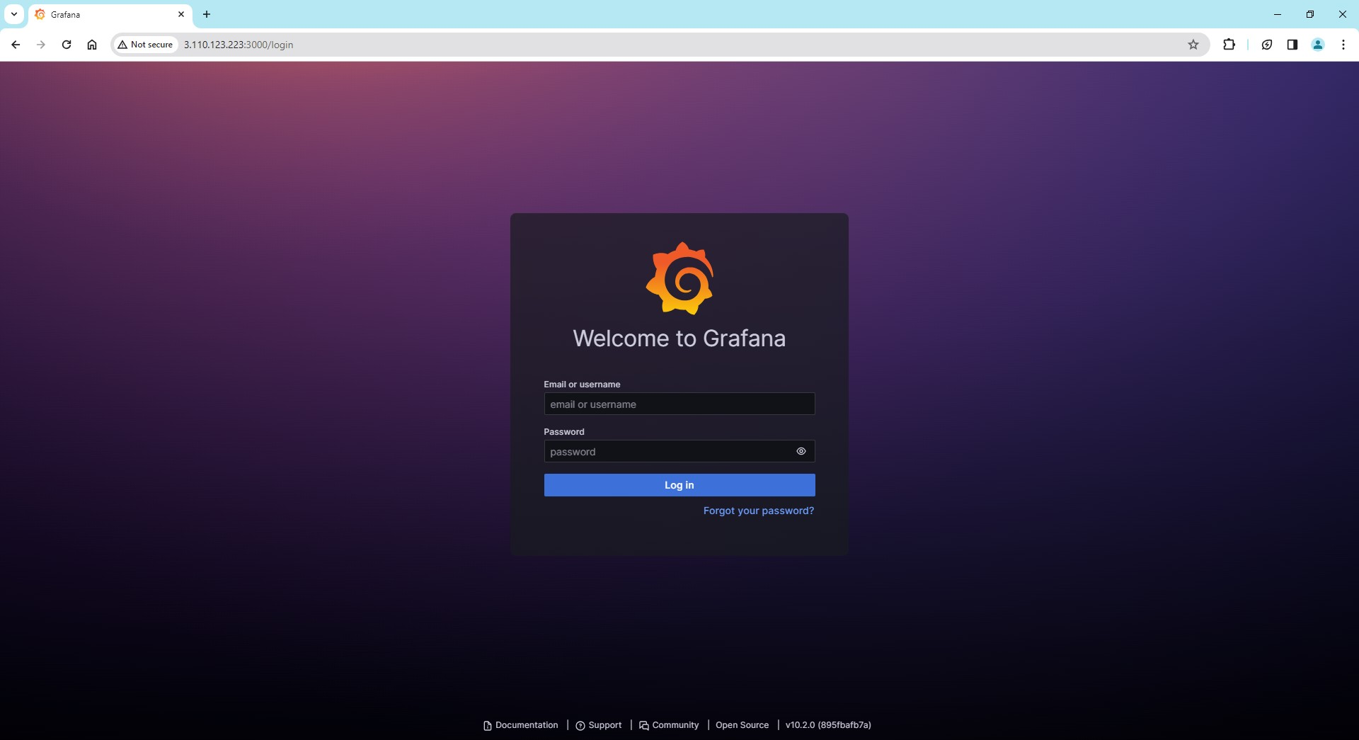

Picturename:46.grafana login page

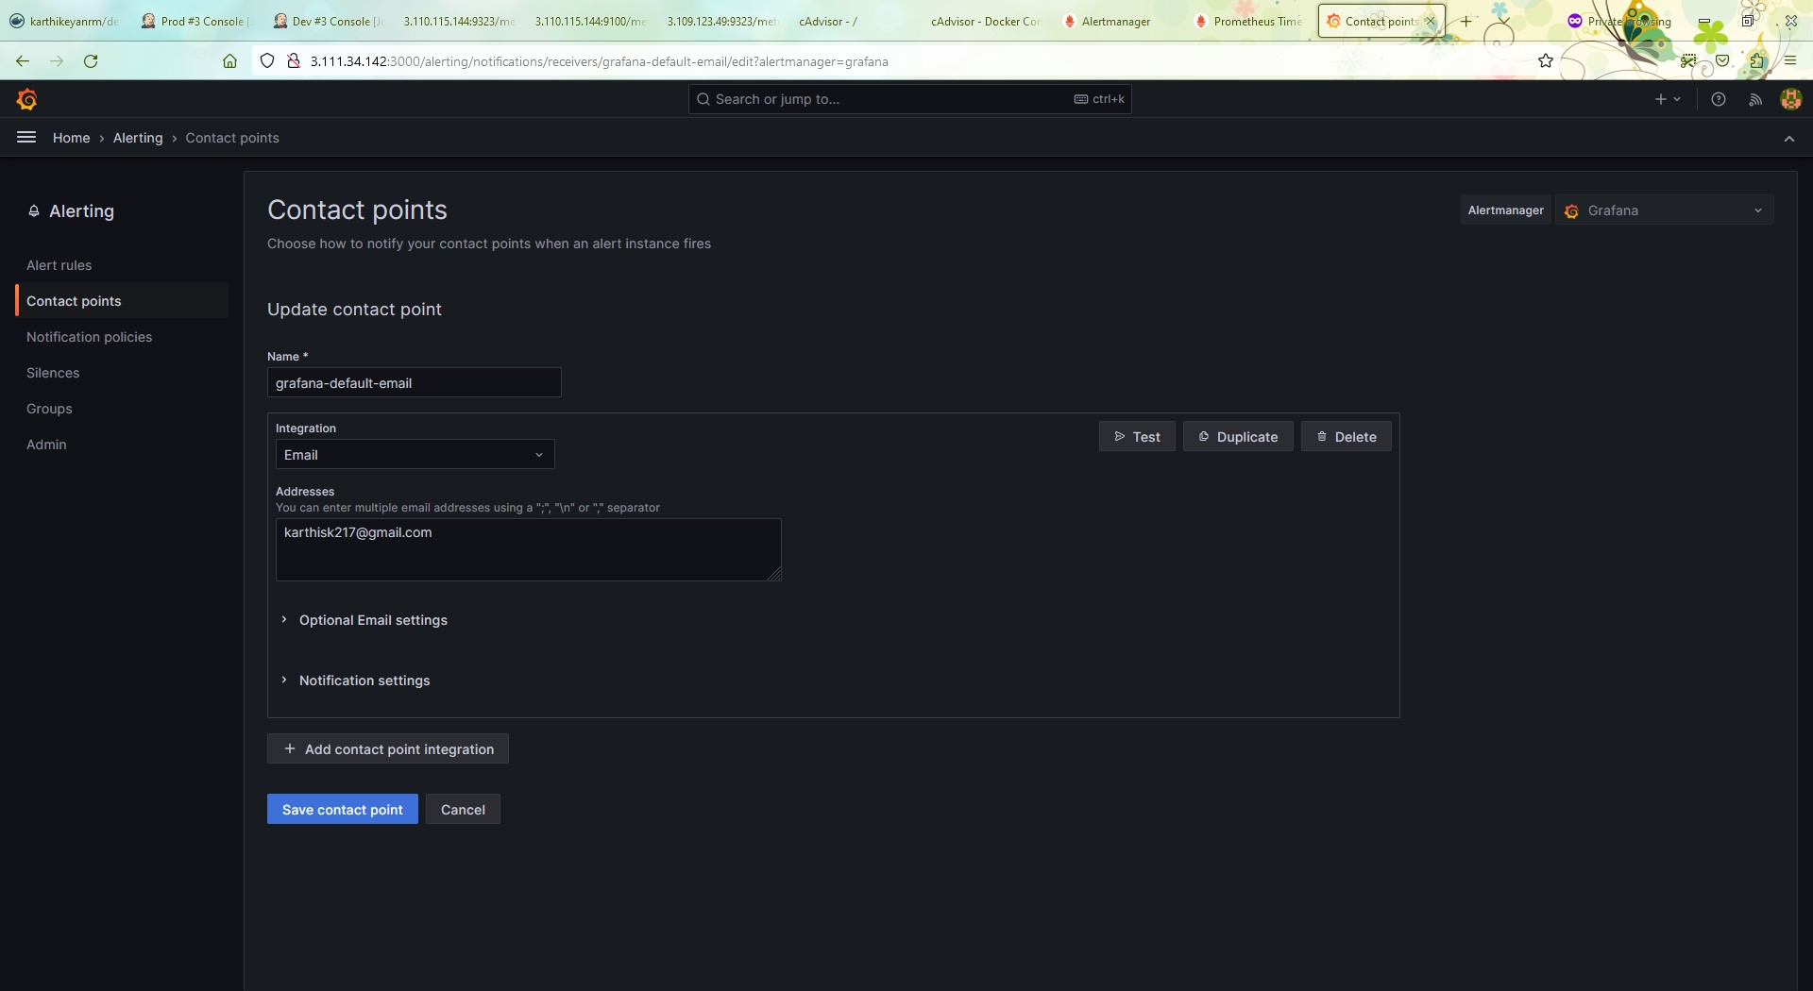

Picturename: 47.grafana alert testing configuration on UI

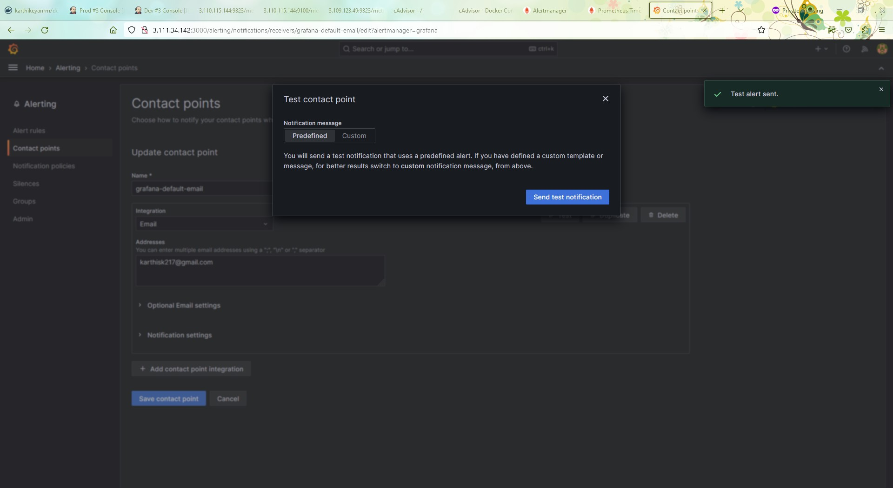

Picturename: 48.grafana alert testing

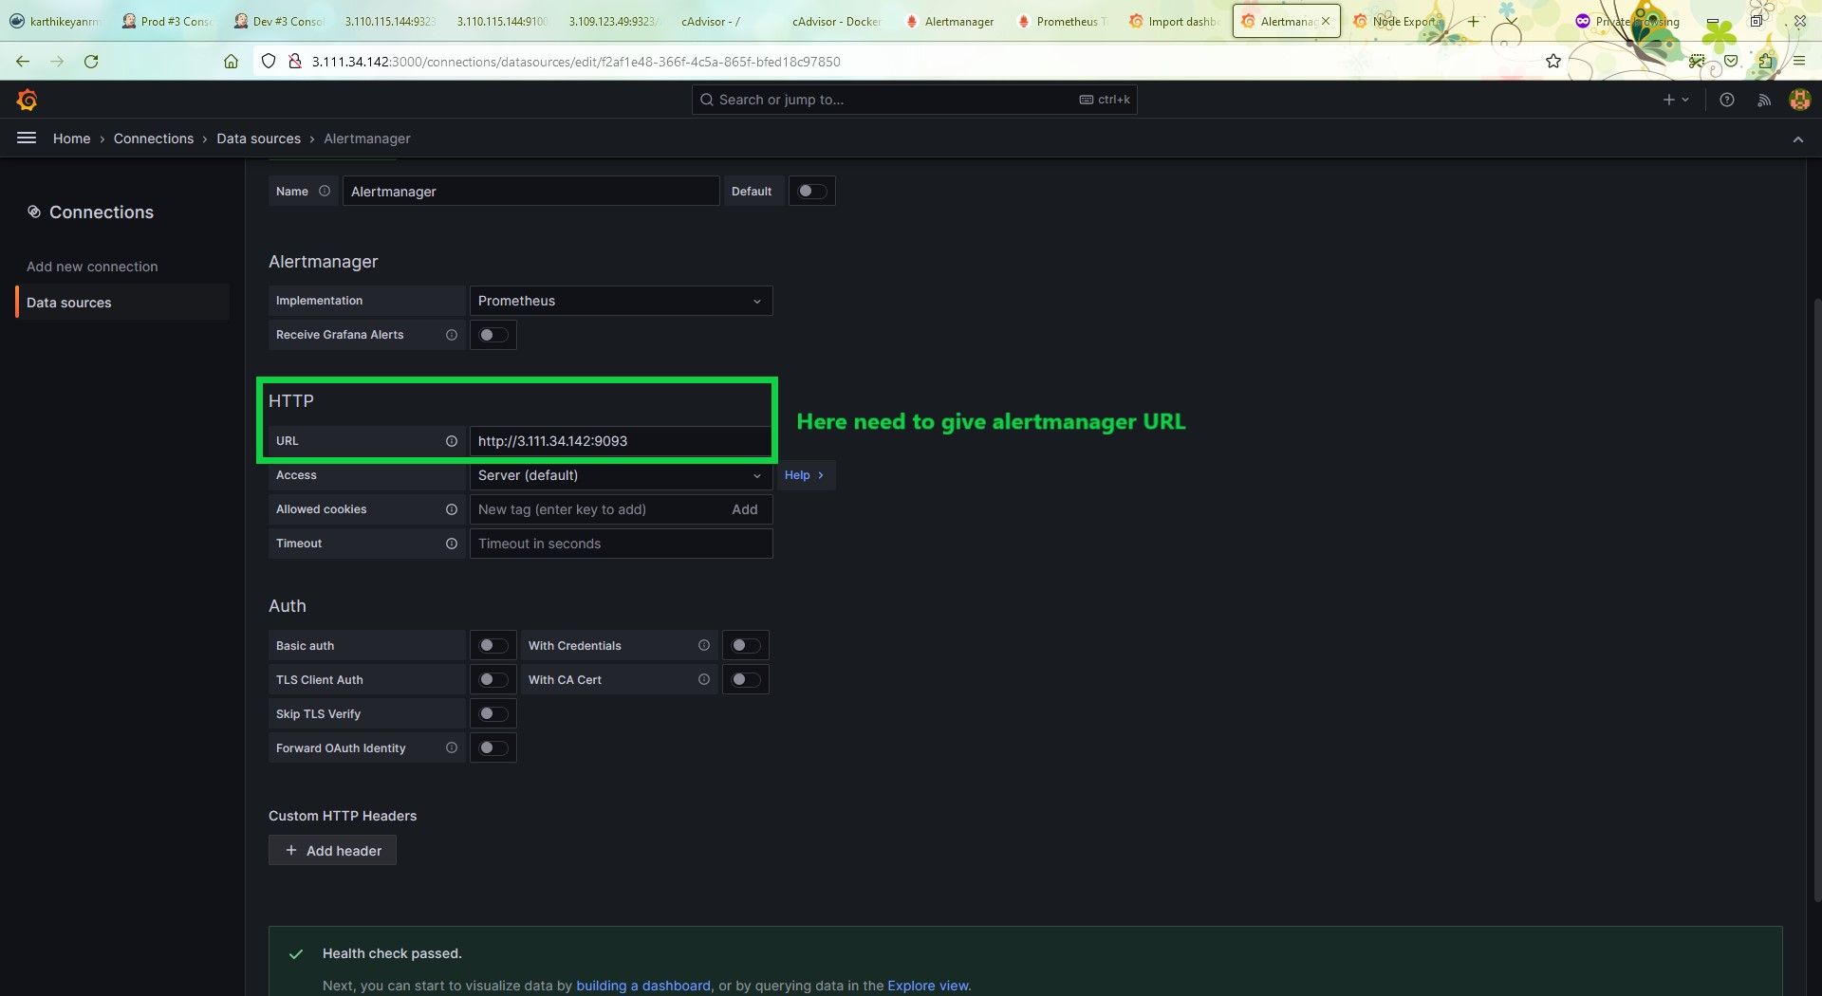

Picturename: 49.Grafana alertmanager datasource add

If the sg allowed form the server is private ( referred sg ) means need to use the private ip

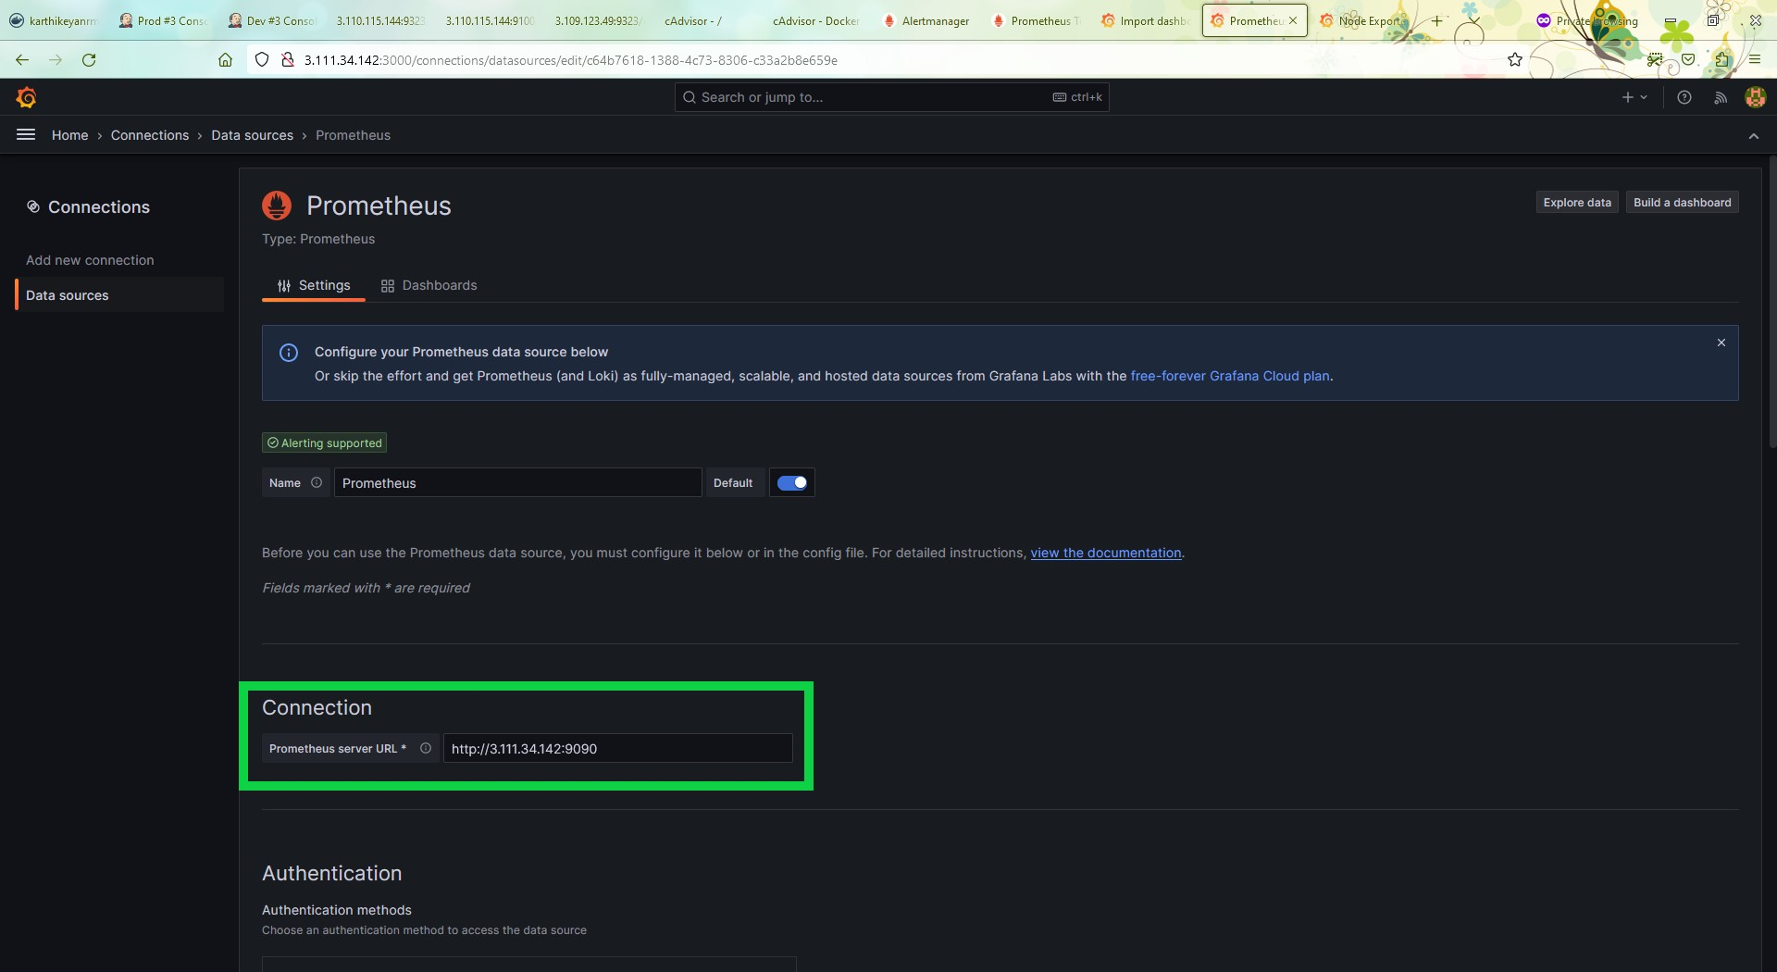

Picturename:50.Grafana promethus datasource add

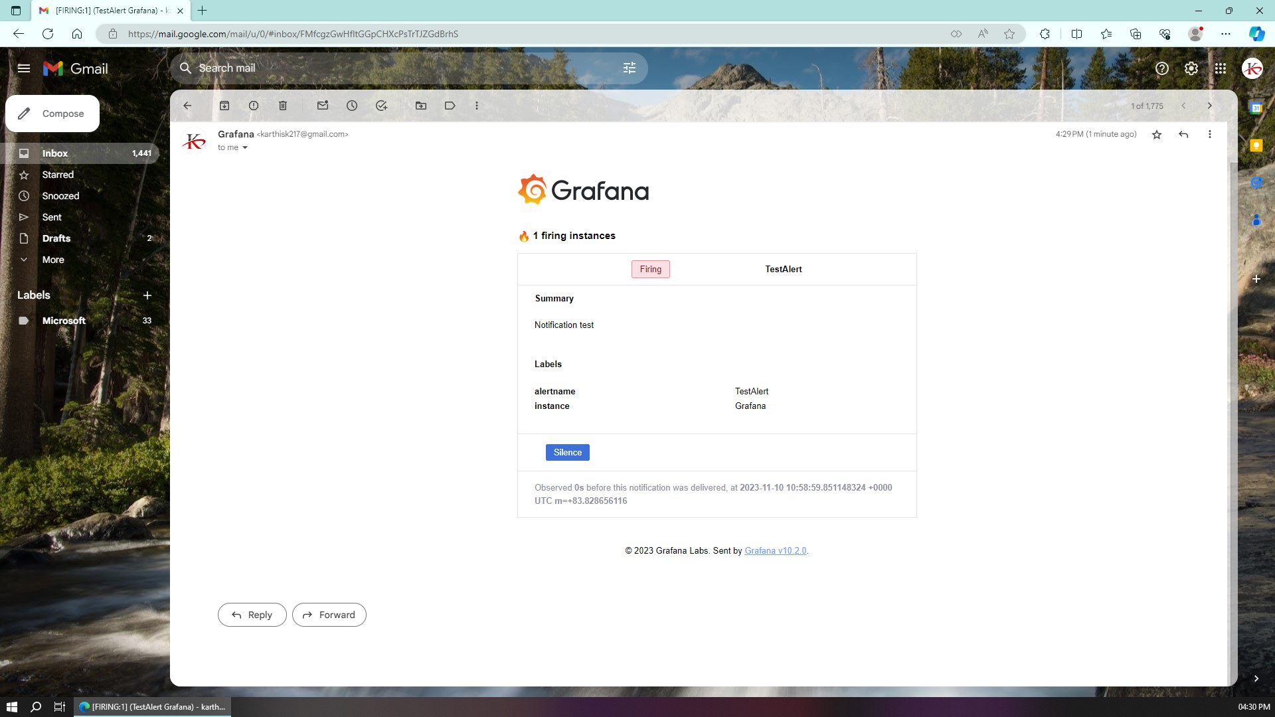

Picturename:51.grafana alert test email

**The below picture**

**Cadvisor Ui which is used to collect the docer containers complete status**

**With the help of docker daemon getting the engine status**

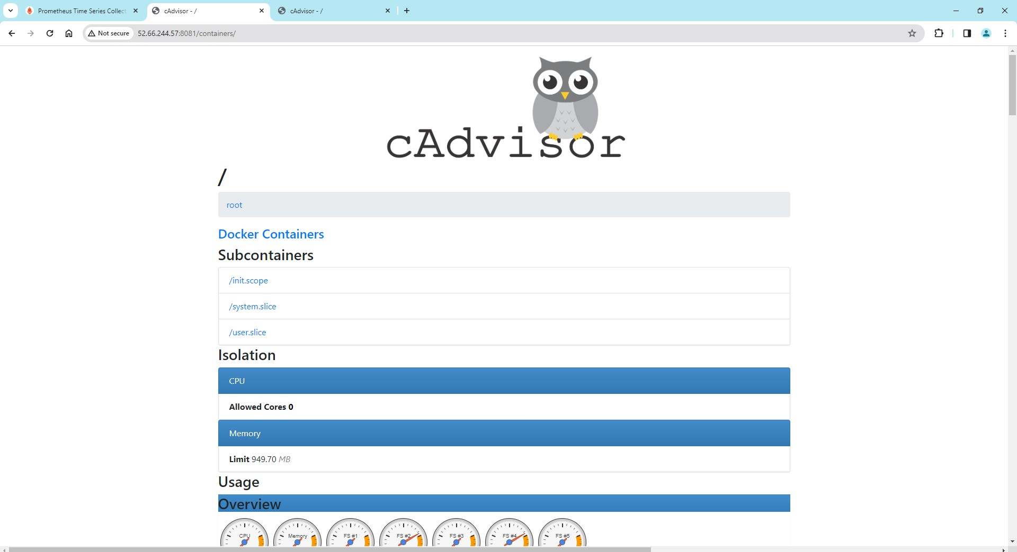

Picturename: 52. cadvisor UI

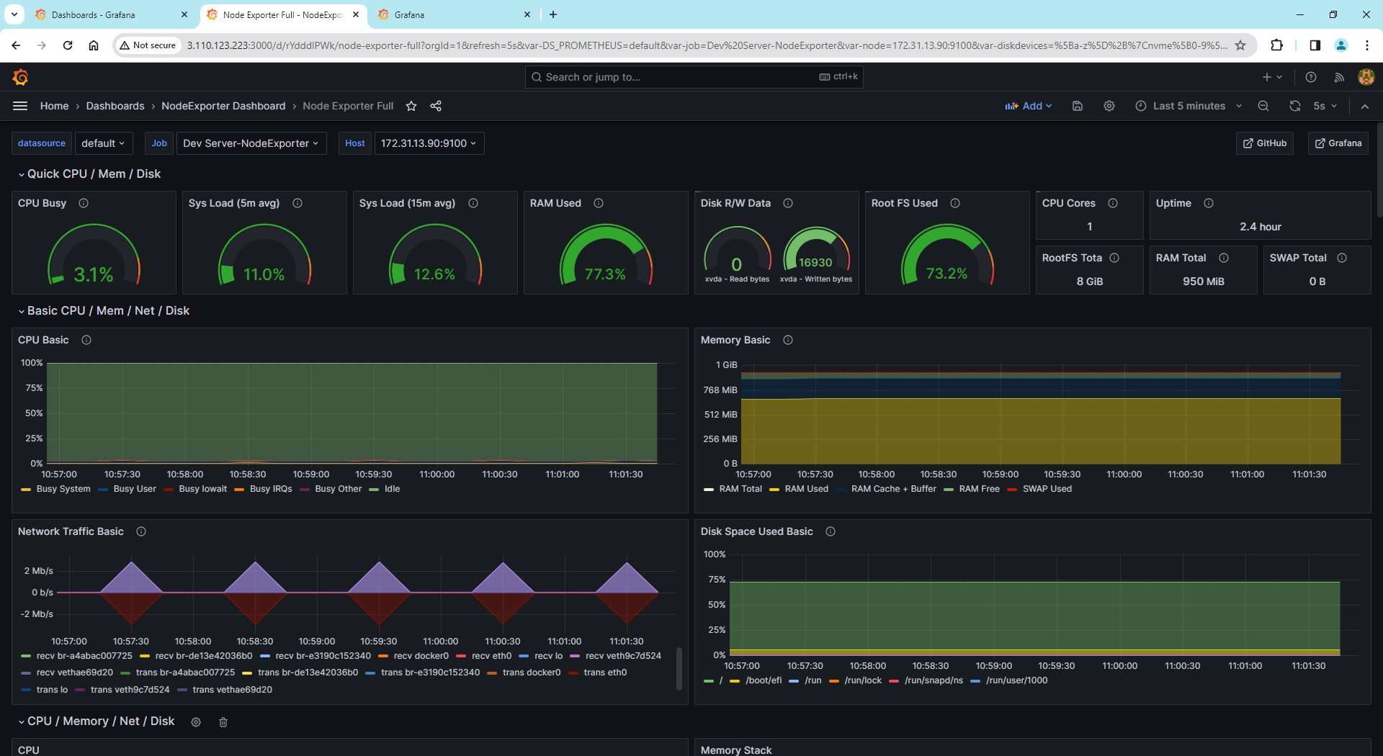

Picturename:53. grafana Nodeexporter dashboard for DevServer(1)

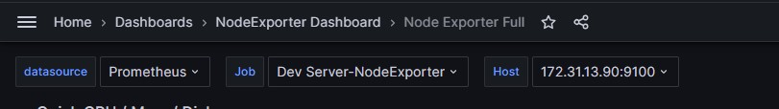

Picturename:53. grafana Nodeexporter dashboard for DevServer(2)

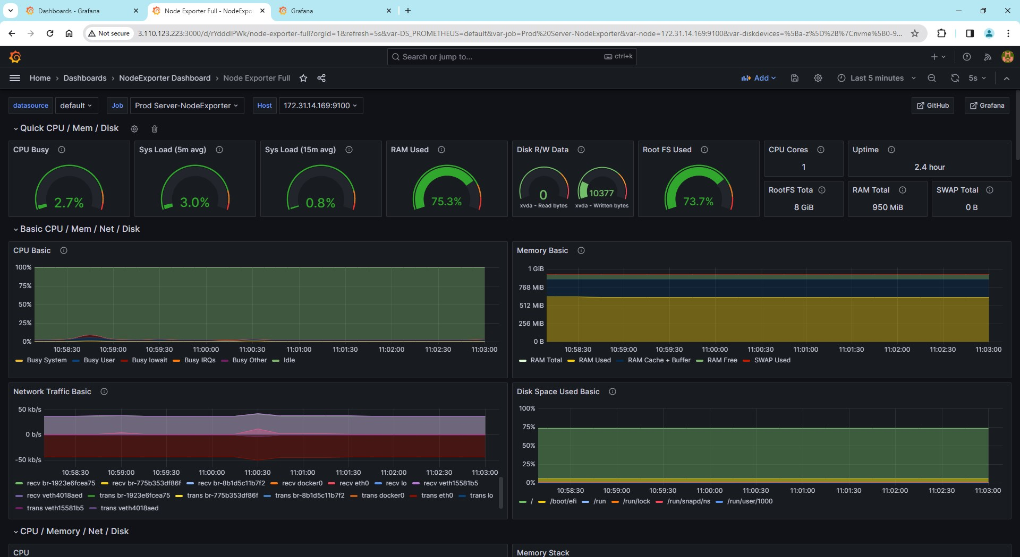

Picturename:54. grafana Nodeexporter dashboard for ProdServer(1)

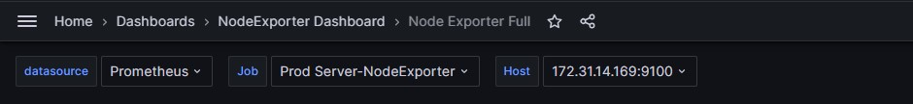

Picturename:54. grafana Nodeexporter dashboard for prodServer(2)

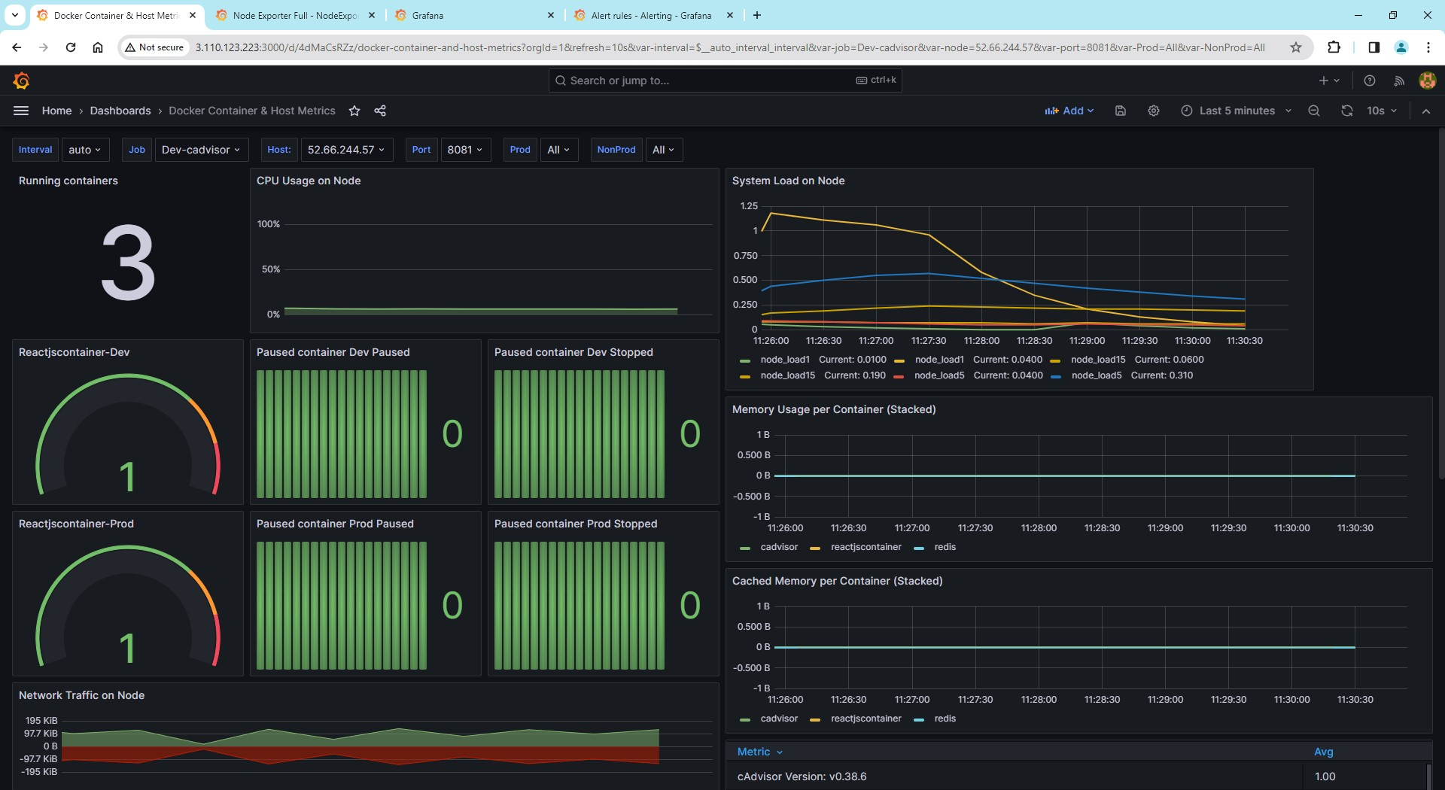

Picturename: 55. grafana dev Docker container and Host metrics customised dashboard

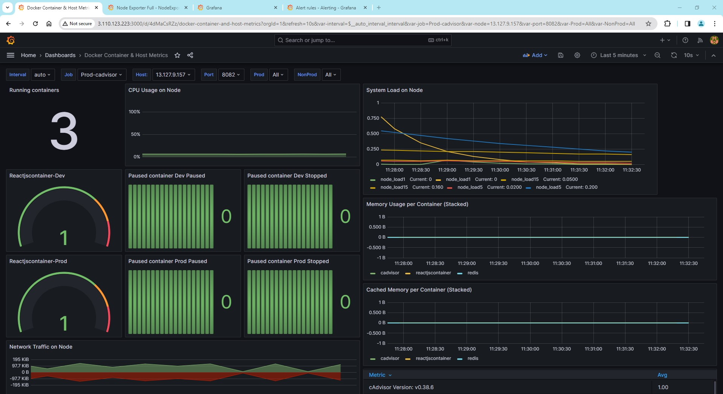

Picturename: 56. grafana prod Docker container and Host metrics customised dashboard

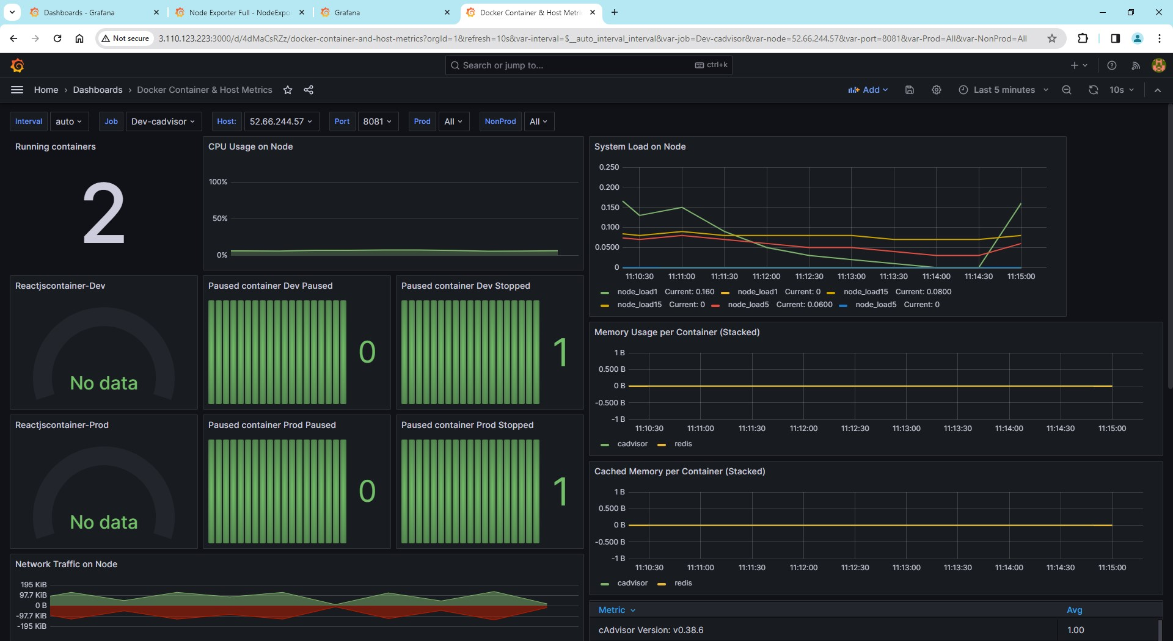

Picturename: 57.Grafana stopped container for dev

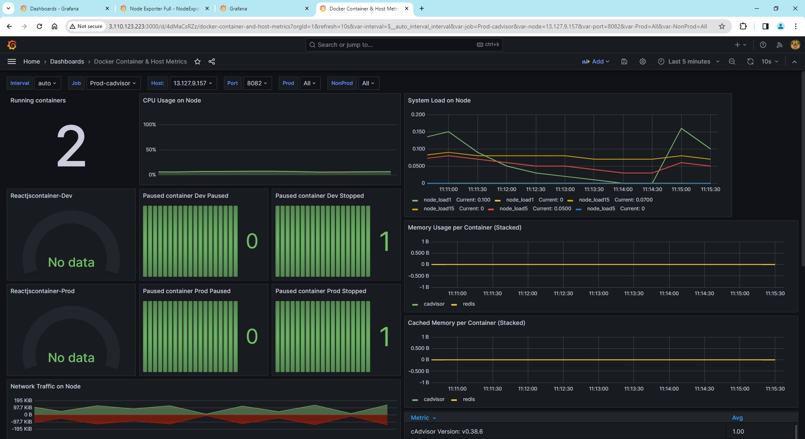

Picturename: 58.Grafana stopped container for prod

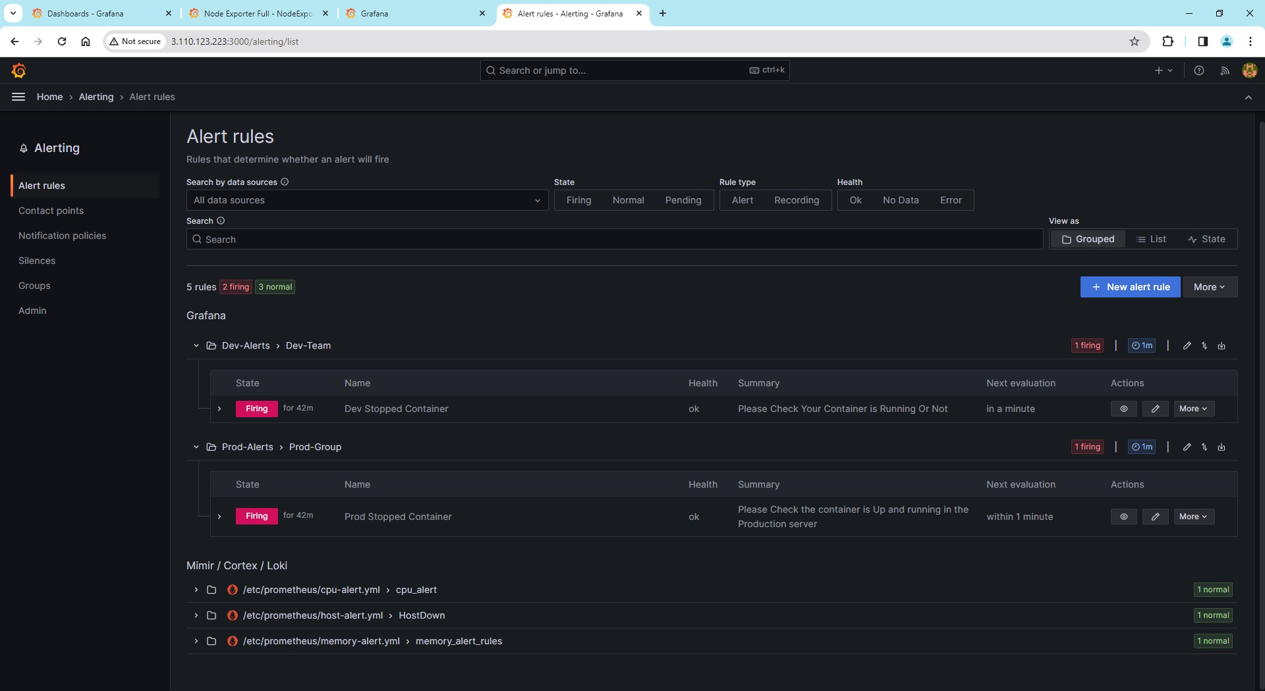

Picturename:59.Grafana configured alerts for dev and prod if reactjscontainer stopped

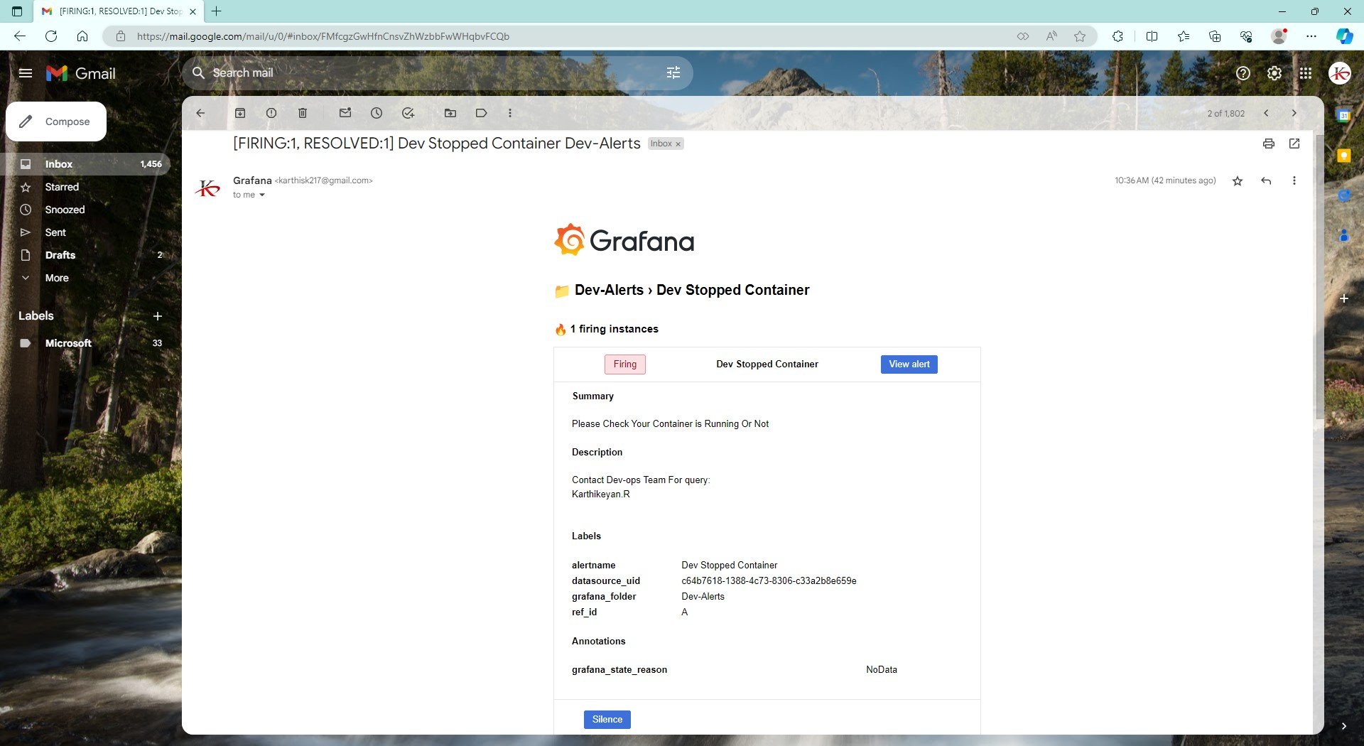

Picturename: 60.Grafana Email triggered for the dev reactjscontainer stopped

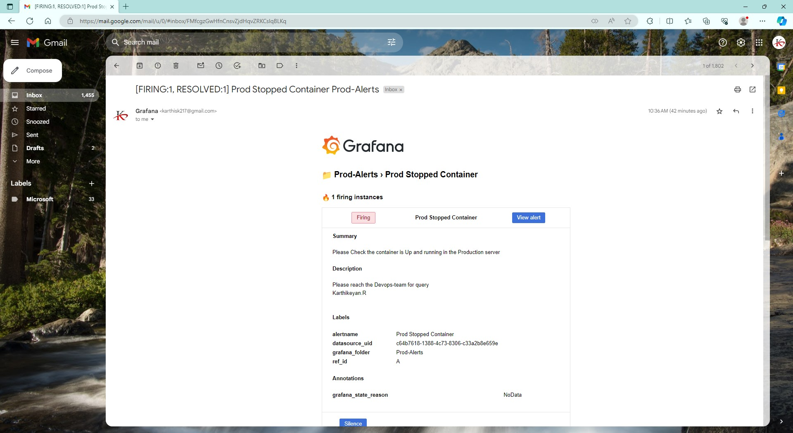

Picturename: 61.Grafana Email triggerd for the prod reactjscontainer stopped

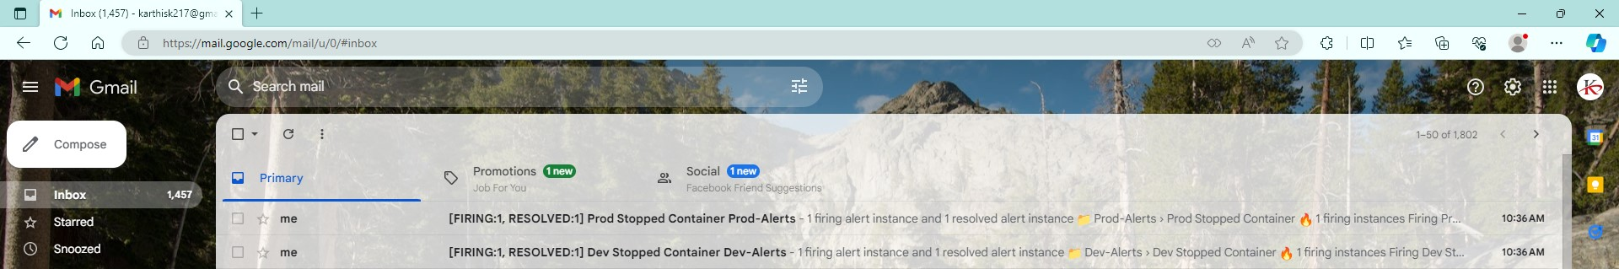

Picturename: 62.Grafana Email triggered for the reactjscontainer stopped

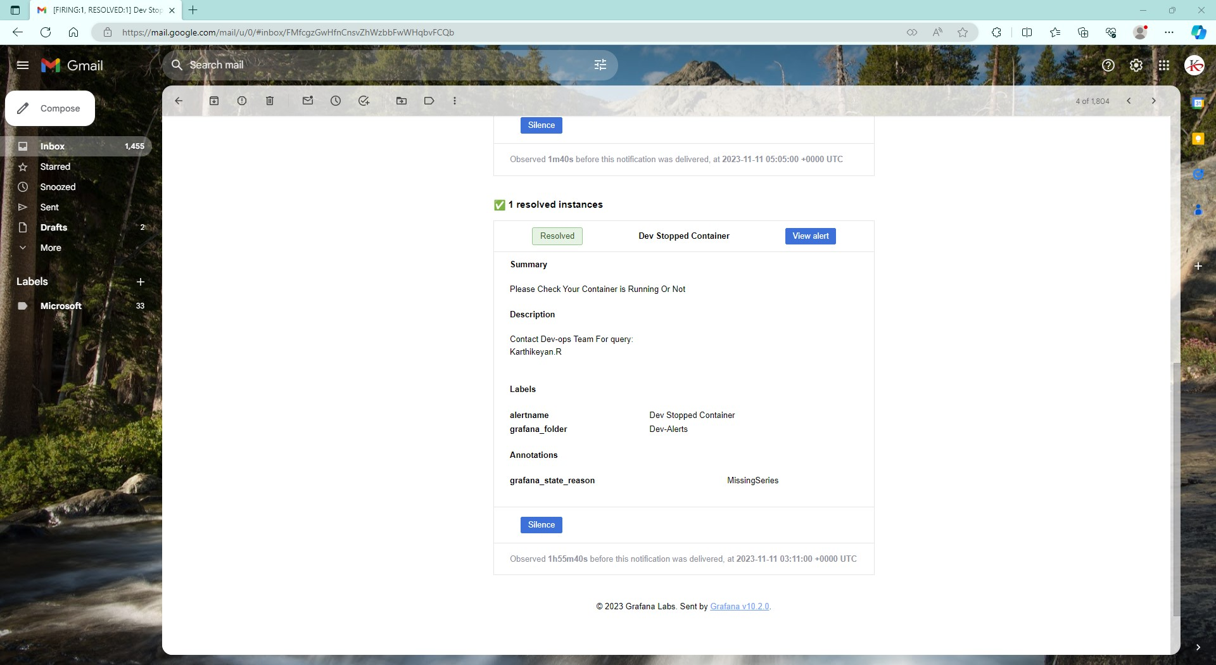

Picturename:63.Grafana resolved Email triggerd for the reactjscontainer running

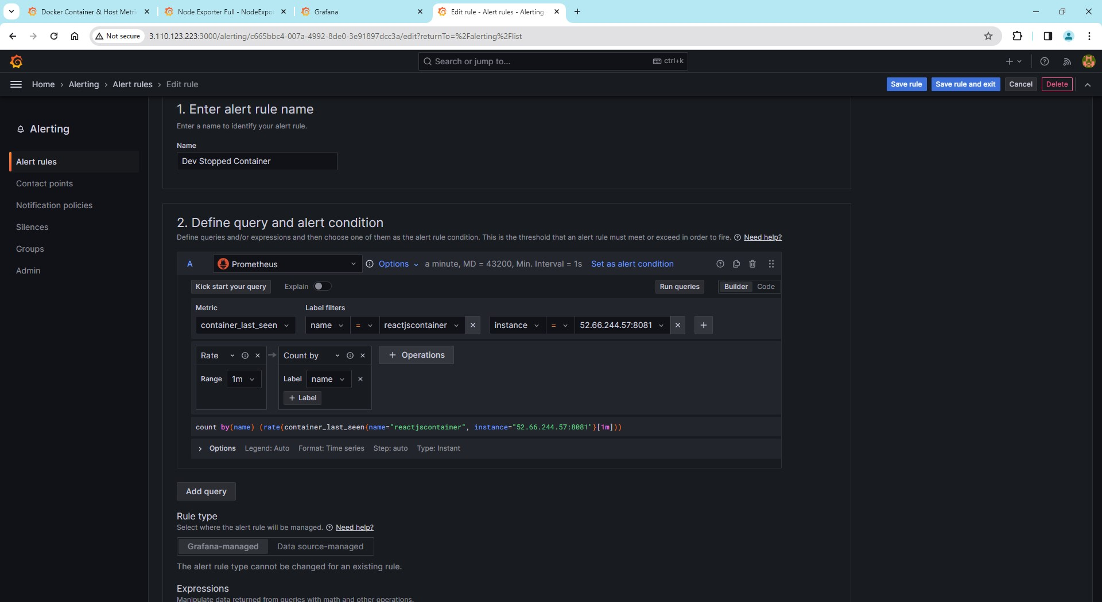

Picturename: 64.Grafana alert config for dev container (1)

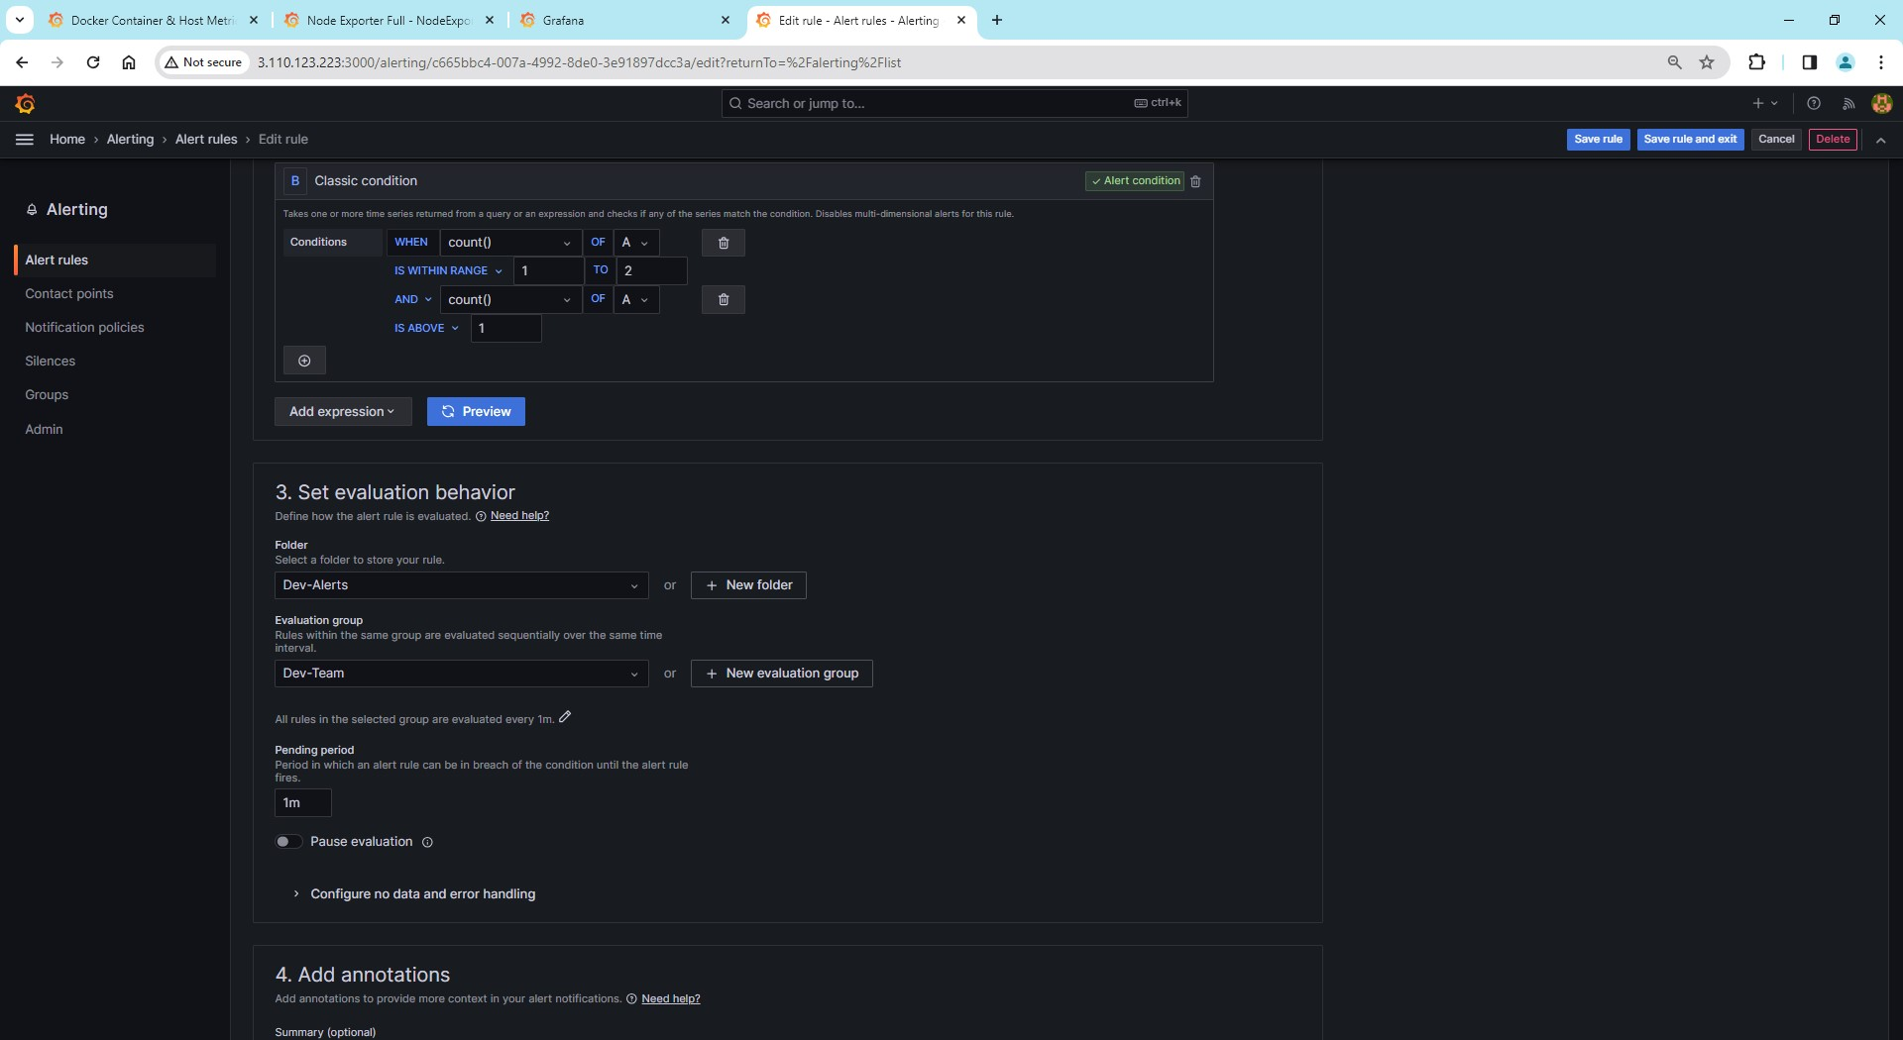

Picturename: 64.Grafana alert config for dev container (2)

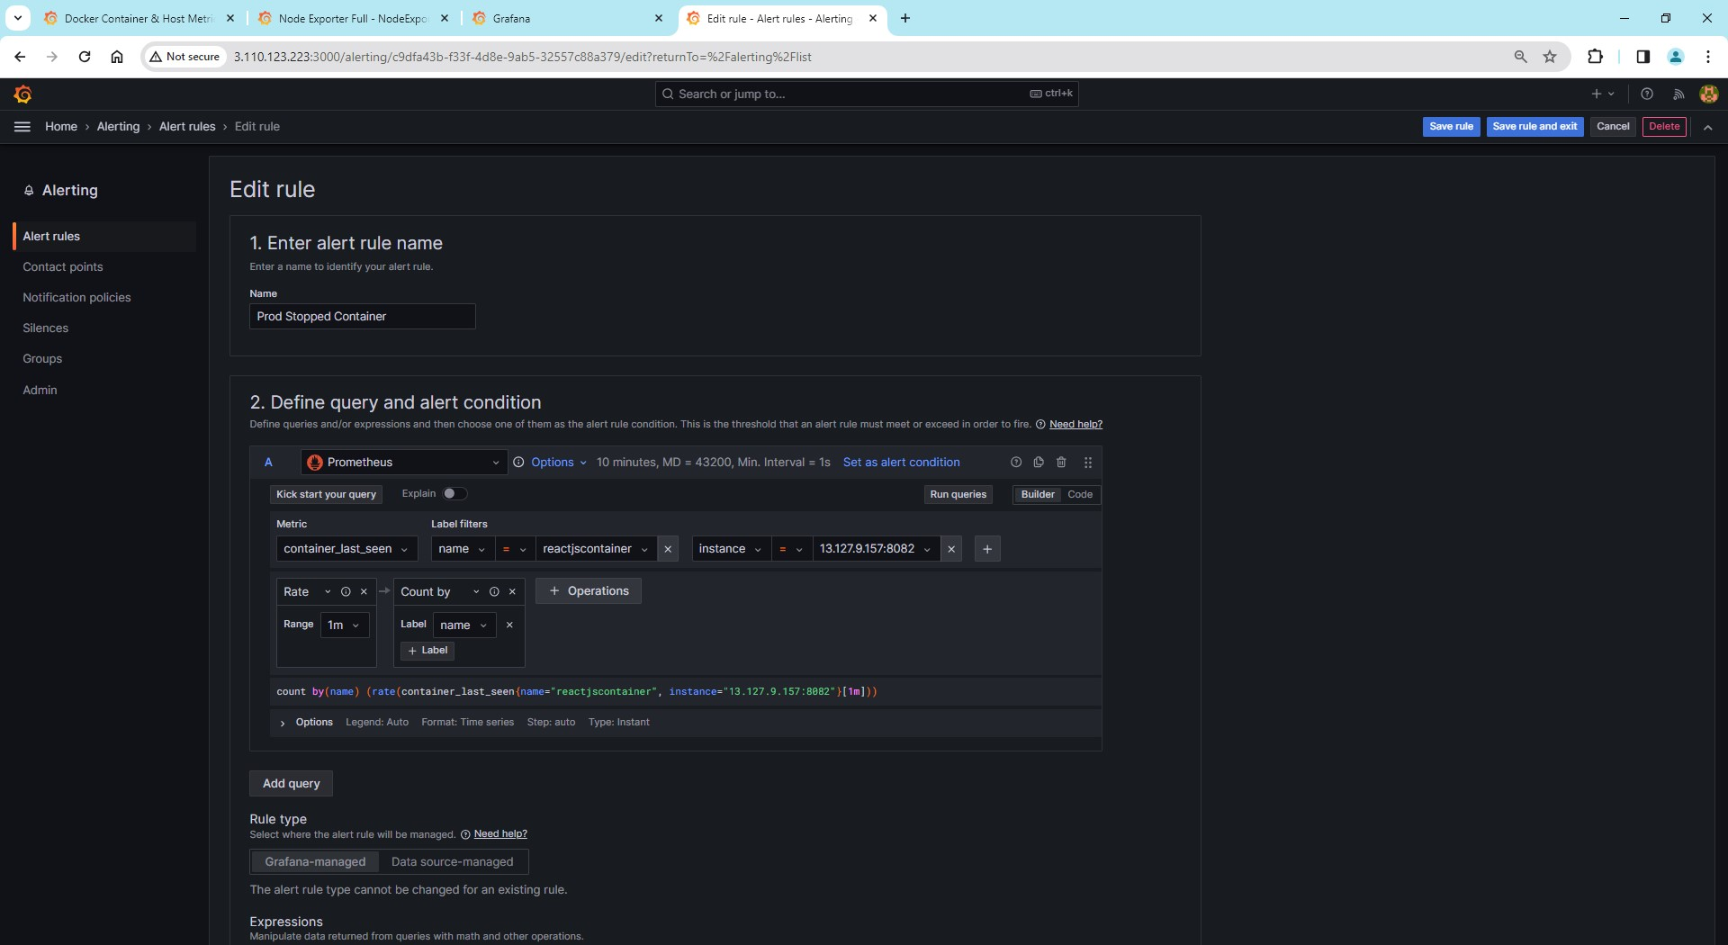

Picturename: 65.Grafana alert config for prod container (1)

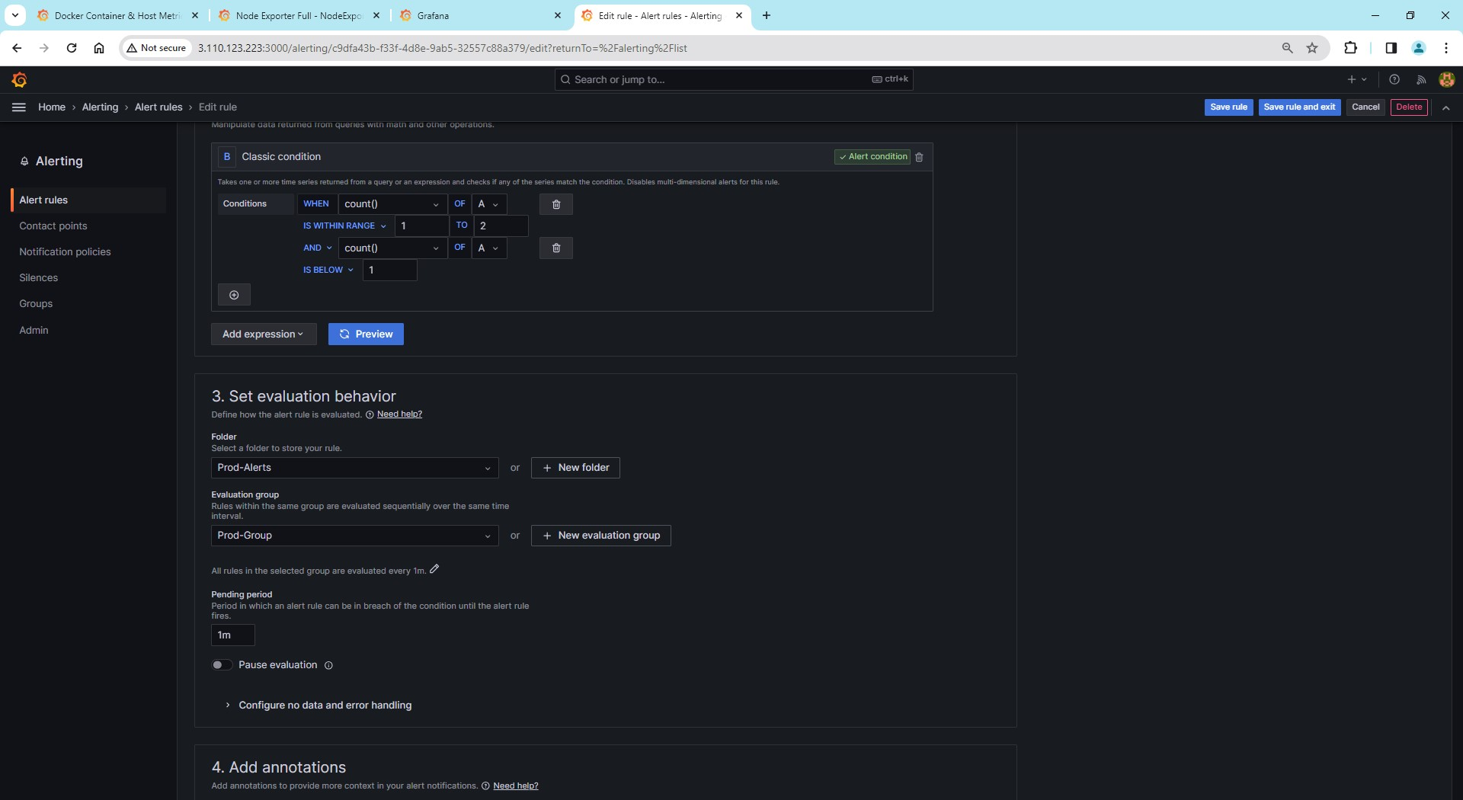

Picturename: 65.Grafana alert config for prod container (2)

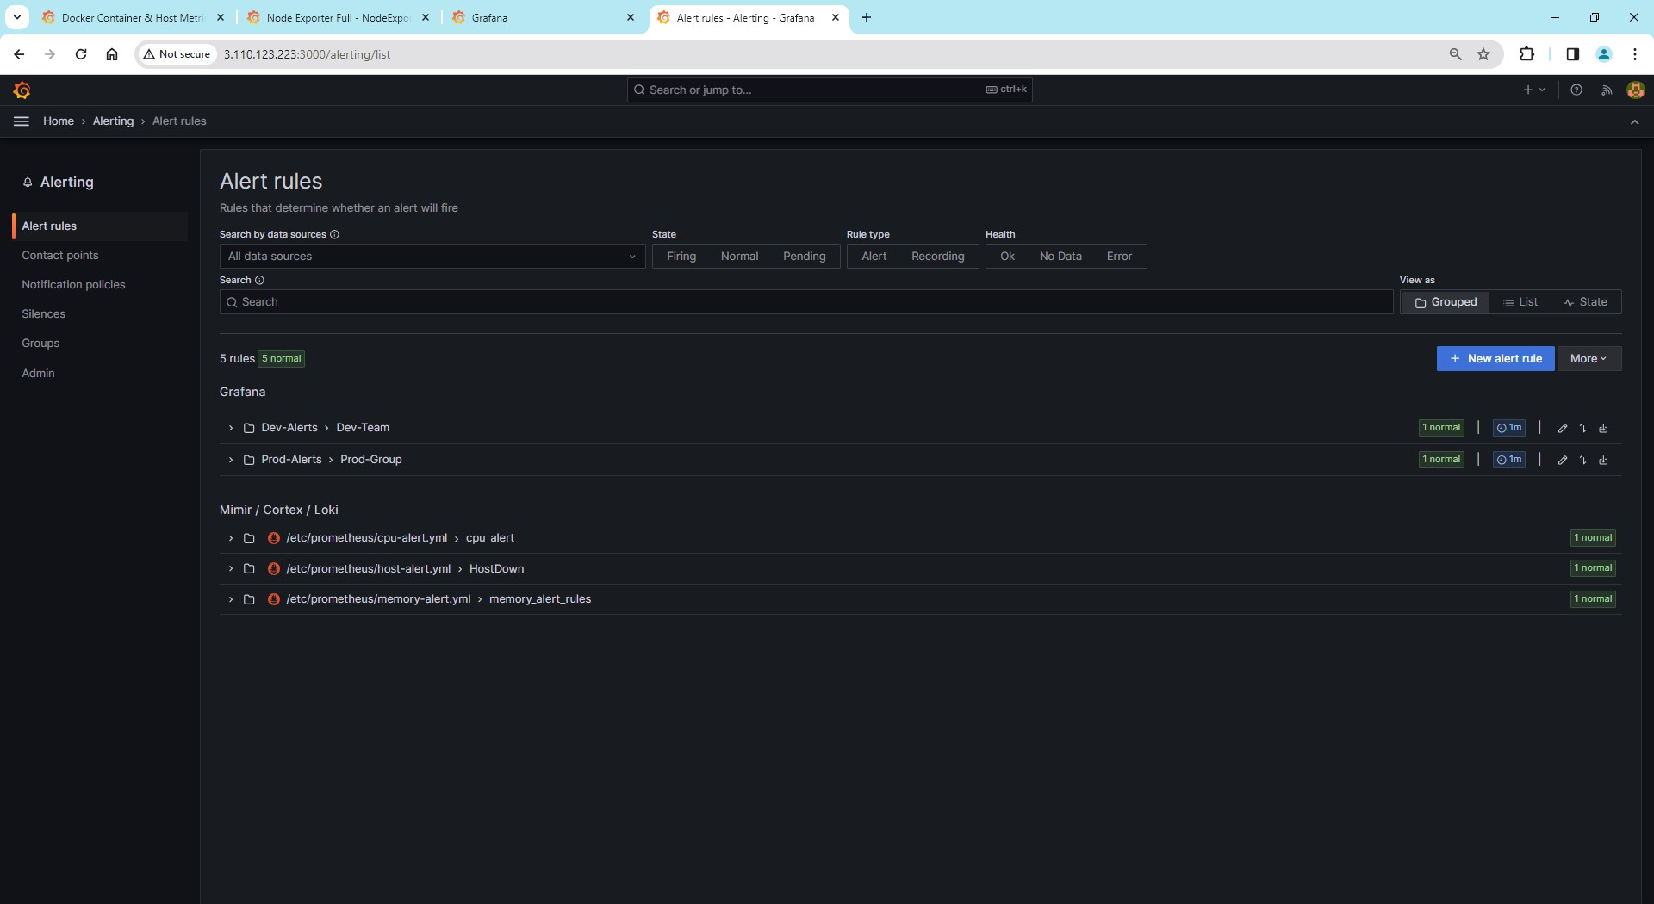

Picturename: 66.Grafana and prometheus alerts are normal state

**The below picture:**

**Here is panel on grafana dashboard i created the same configuration for the dev and prod modified for the dev and prod**

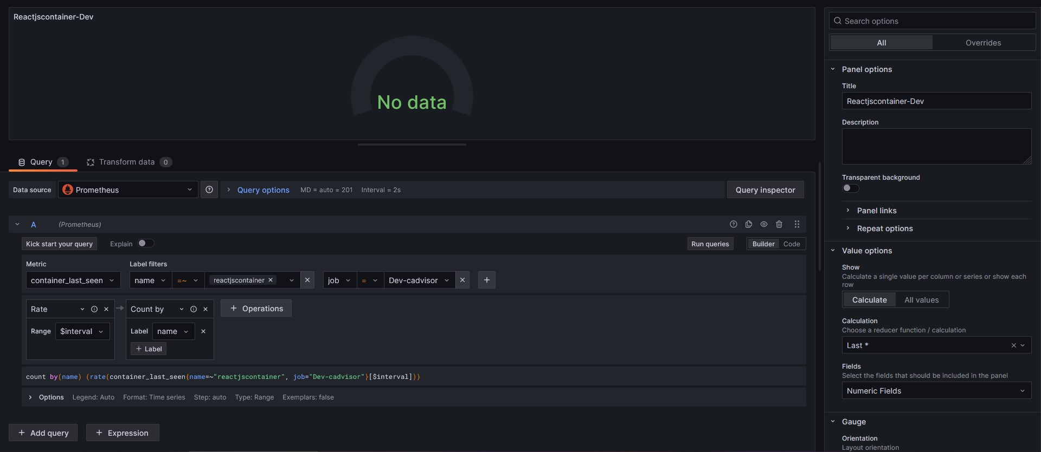

Picturename: 67.Grafana custom pannel to show status reactjs container running

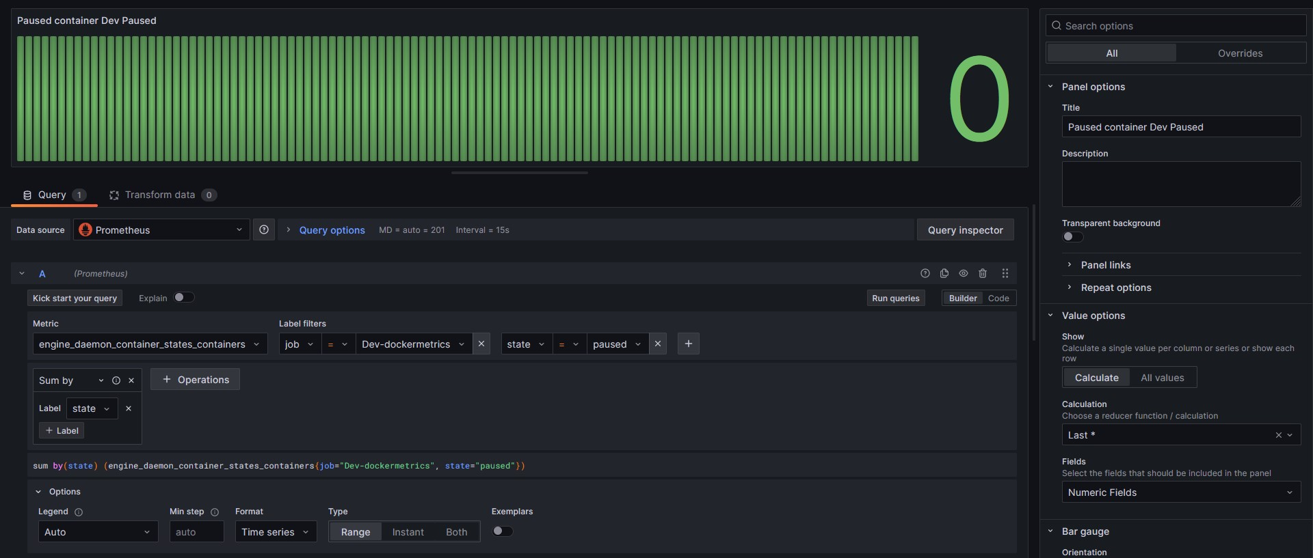

Picturename: 68.Grafana custom pannel to show status reactjs container paused

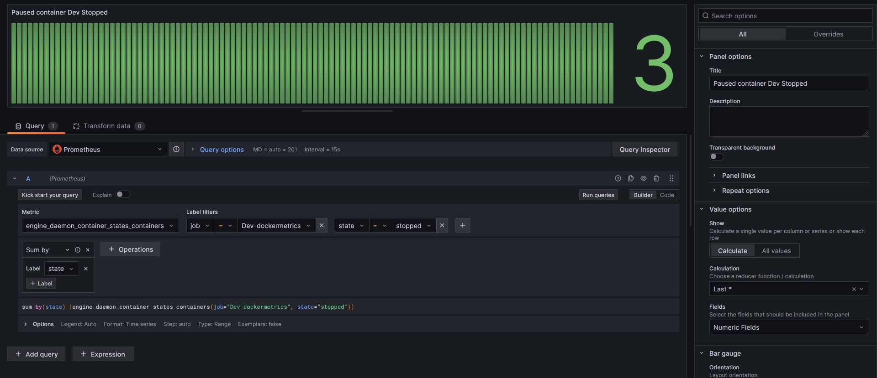

Picturename:69.Grafana custom pannel to show status reactjs container stopped